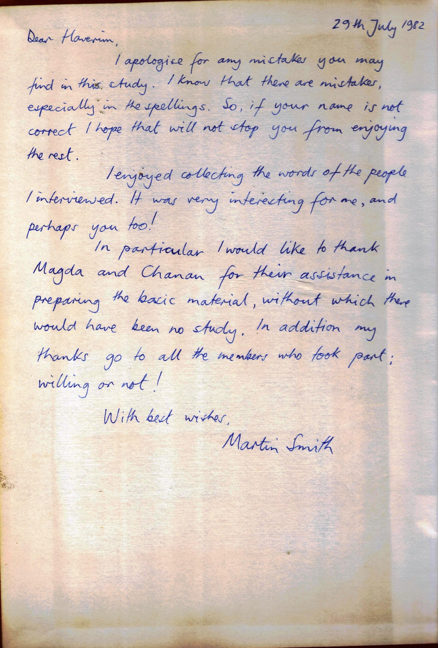

Changes in child care in Kibbutz Sade Nehemya

By

Martin Smith

Submitted in part –fulfillment of the requirements for the degree of B. Phil. (Ed): Field A4 – Emotional and Behavior Difficulties

The University of Birmingham

1978-80

**Contents**

|  |  |
| --- | --- |
| Page no. | Chapter |
| 2 | Chapter I : Introduction |
| 3 | Basic Information |
| 4 | " The Movement" |
| 5 | Kibbutz Values |
| 8 | Beginnings |
| 14 | Chapter II : Method of Investigation |
| 17 | Chapter III: What was the kibbutz like originally? |
| 27 | Chapter V**:** Why did Children's sleeping arrangements change? |
| 27 | An account of how it happened |
| 29 | Outside Influence |
| 31 | Changing is difficult |
| 33 | Financial Considerations |
| 34 | Who wanted to change the rules? |
| 35 | Discussions |
| 37 | What are the benefits of the new system? |
| 40 | How will the Kibbutz develop for children? |
| 47 | Conclusions |
|  |  |
|  | Appendices |
|  |  |
| 49 | I: Original questions |
| 50 | II: Chronology |
| 51 | III: Backgrounds of Informants |
|  |  |
| 55 | Bibliography |
|  |  |
|  |  |



Chapter 1

INTRODUCTION

The Kibbutz way of life is very different from our own and significantly different from other experiments in group living.

Anywhere in the world the practice of bring up children is of a fundamental concern and that is why the Kibbutz method incites interest; it is unlike any other.

This particular aspect of Kibbutz life has received much attention from

Western educationists and sociologists. As Rappaport (1958) puts it,

'The upbringing of children in the agricultural collectives in Israel is for

the social scientist what an "experiment of nature" is for the natural scientist.'

The intensity of the debate that used to surround this subject indicates the degree of importance given to particular perception of the family and the willingness with which they were defended.

I spent four months on a Kibbutz in 1967 and left impressed with the fact that communal life worked. Last year I was visited by a member of that Kibbutz and as a result of what he told me I had to revise my views. He explained that although the democratic process had not changed,life was very different from the way if was twelve years ago. From what he said it seemed that a few of the principles I had heard about had been changed. The most important of these was that the children lived as a group from an early age. I learned that now the children slept at home.I resolved to find out why.

The literature available was either out of date (Spiro,1955,1958;Weingarden,1955)biased(Leon,1969;Bowlby,1951)or misleading and out of date(Bettelheim,1969).Little I have read has been up to date. I wanted to find out myself what changes had taken place since my previous visit. On future consideration I decided to concentrate on the changes in child care. It would be relatively easy to see what changes had been made but I was more interested in why.

BASIC IMFORMATION ABOUT KIBBUTZIM1 ACCORDING TO MADER (1972)2

1. In 1972 there were about 241 Kibbutzim in Israel with a population of approximately 90,000 people. This figure includes members, children, parents of members and groups in training.

2. Kibbutzim constitute about four per cent of the Jewish Population

of Israel.

3. The population of Israel in 1972 was 2,300,000.

4. Each Kibbutz belongs to a federation which has a political a affiliation.

A breakdown is given below:

|  |  |  |
| --- | --- | --- |
| **Number of Kibbutzim** | **Political Affiliation** | **Federation** |
| 76 | Mapam  (left-wing) | Artzi Hashomer Hatzair |
| 61 | (right-wing)  Achdut Ha'avodah(part of the Israel Labour Party) | Hakibbutz  Ha Meuchad |
| 89 | (center)  Mapai  (part of Israel Labor Party) | Ichud HaKvutzot  Ve HaKibbutzim |
| 15 | (religious)  National Religious Party | HaKibbutzim  HaDati |

5.The center and right-wing federation amalgamated in August 1979.

To the insinuated the differences between Kibbutzim belonging to

Different federations are rather puzzling. By western capitalist standards

the principle of 'from each according to his ability, to each according to his needs', would seem impossible to achieve.

1. The plural of Kibbutz is Kibbutzim.
2. Mader, M. 1972 "The Reality of the Kibbutz" Kibbutzim Representatives London.

This idealistic tradition grew out of a European movement which has its roots in Marx, socialism and a strong anti-Jewish family feeling. Below is a typical Kibbutznik1 background:

My parents were idealistic. They came from a quite religious

European family. They came to Palestine as pioneers to burn and break everything from home. They started from the beginning

again. As a child I didn't know dates of the Jewish festivals. They

considered it unnecessary. What is important is working the land

and being faithful. I turned to my roots.

(Offrah)

It would be rewarding to investigate the origins of these would-

be Jewish farmers who came with such missionary zeal to such

an inhospitable land.

**'THE MOVEMENT'**

'The movement' was a confluence of the European historical streams of thought; the European Youth movement and Zionism. All

The founders of Sade Nehemya were in the movement in Europe, as

were many of those who followed in the forties and fifties. Zionism, as

propounded by Herzl, began to influence these youth groups after the pogroms in Poland when it provided the incentive to emigrate to Eretz

Israel.

At the turn of the century the Wandervogel2 movement embodied this idea of migrating to a new world; of youthful ideas perhaps? What it held for young Jews was an opportunity to dispense with the authoritarian families in which they found themselves. According to Laqueur3 (1962) what they wanted was a more down to earth way of life not reflected by the Autocratic nature of their schooling or family.

-----------------------------------------

1. Kibbutznik- a member of the Kibbutz.

1. Wander Vogel means migratory bird.
2. Laqueur, W. (1962) Young Germany: History of the Youth Movement. (Rutledge and Kegan Paul, London.)

Generally speaking a member of this movement was:

A man of truth

Loyal to his people

A brother to his fellows

A helpful and dependable brother

A lover of nature

Obedient to the orders of his leaders

Joyful and gay

Economical and generous

A man of courage

Pure in thoughts, words and deeds.1

There is something naïve about such rules but perhaps I speak as one who can only feel disillusion as if being grown up was incongruent with enthusiasm. This code reminds me of my boyhood scouting days when such things had meaning. It creates a picture of young people escaping to nature by walking and camping rather than revolting against society and their parents. Perhaps it led them to opt for farming when they arrived in Israel.

This idealistic movement is the root of what became the Kibbutz

Ideology, because although it stressed the importance of individual free-

Dom, self-expression and freedom from the group, 'it was not long before the group…..began to assume great importance.'2

**KIBBUTZ VALUES**

It is incumbent on me to explain something about the values these

Ideologues brought with them. These original principles will give the reader a base line which has largely receded into history by now.

1. **Self Labour**

The foremost tenet was the value of self-labor. Labor was seen as the essence of their lives. They held that self-labor stressed the dignity and creativeness of the self. It also implied not using cheap labor which the vatikim1 saw as exploitation.

1. Spiro, E. M. Children of the Kibbutz, p. 46
2. Ibid., p. 47.

2**. Hierarchy 0f Labour**

In the early days there was even a very clear hierarchy of labour so that agricultural labour was regarded more highly than service work.

'Prestige according to Spiro (1958), 'was determined primarily by excellence in and devotion to one's work.'2 Coming largely from closed Jewish towns (shtetl) and villages in central Europe where scholarship and not labour was prized, the earliest immigrants contrived to turn the existing conventions on their heads. Significantly, it was the young middle-class intellectuals who deliberately chose to be workers. 'Instead of aspiring to "rise" in the social ladder, they aspired "to decend".'3

3. **Property**

All property on the Kibbutz is owned collectively. The individual owns only small personal effects. All individual members have the same clothing allotment, eat the same food in the communal dining room and enjoy the same housing conditions. These rights hold in spite of an individual's contribution.

4**. Liberty**

Individual liberty was safeguarded by the rotation of all offices every two years. There was no curtailment of free speech.

5. **The Group**

The basic unit of the Kibbutz was the whole group. This meant that

the interests of the individuals were subordinate to the group. Individual behavior was expected to be directed towards the promotion of the group's interests. Group experience was valued more highly than individual's.

1. Vatikim – veterans.
2. Spiro ( 1958), Children of the Kibbutz, p. 16

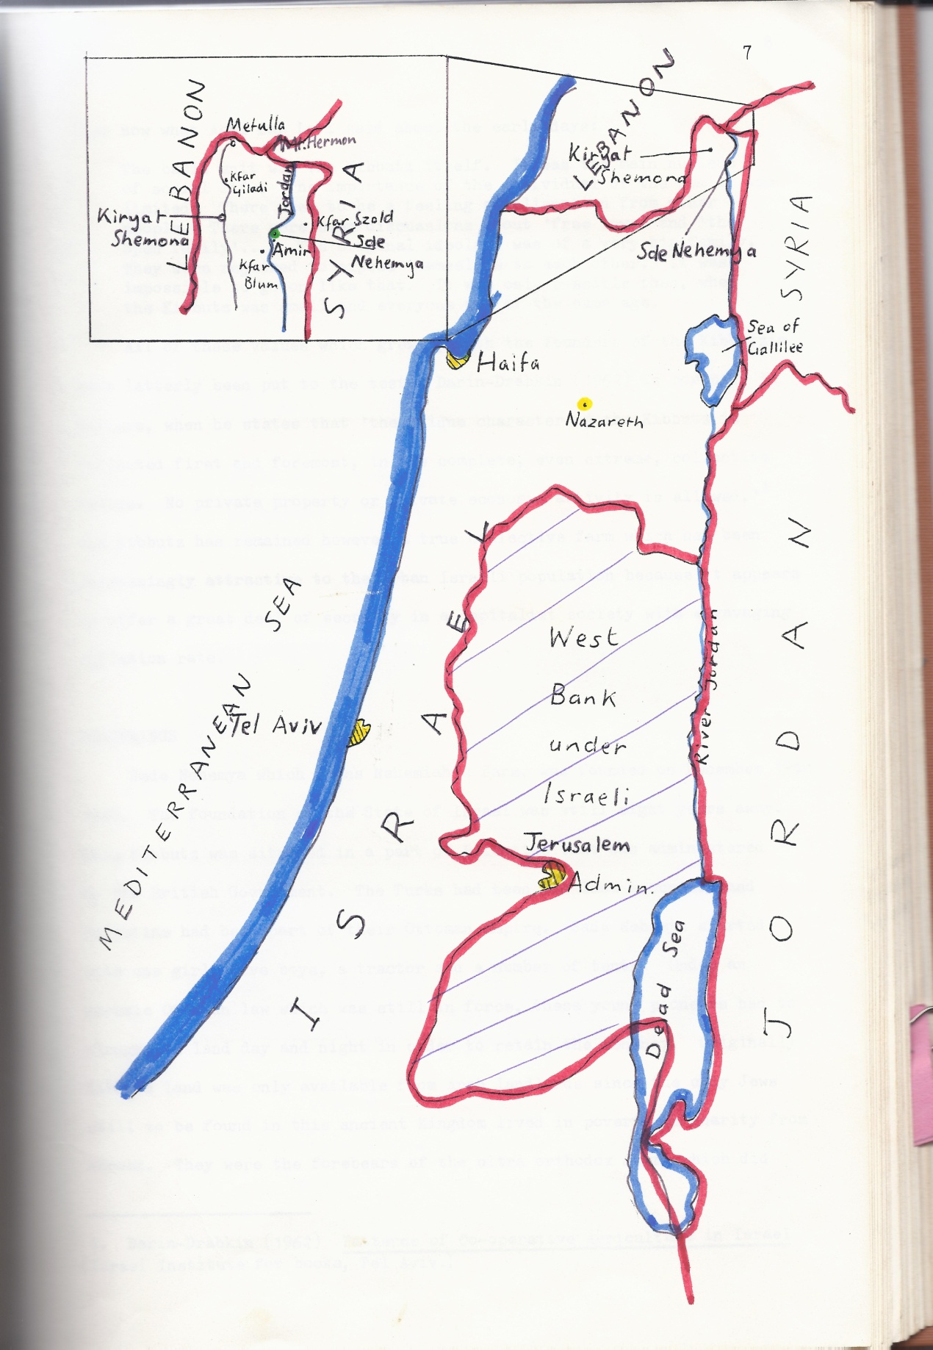

Hear now what Achi Bar Levi said about the early days:

The basic unit was the Kibbutz itself. It was the main nucleus of social life. The importance of the individual of the family was limited. There used to be a feeling of alienation from other people. There were even discussions about 'free love' and 'the open family'…. The original ideology was a very big family. They were required to expose themselves to each other. It was impossible to go on like that. It was only possible then, when the Kibbutz was small and everyone was of the same age.

All of these values which grew up with the founders of the Kibbutzim have latterly been put to the test. Darin-Drabkin (1962) is correct, I believe, when he states that 'the unique character of the Kibbutz is reflected first and foremost, in its complete, even extreme, collective

nature. No private property or private economic activity is allowed.'1

The Kibbutz has remained however a true collective farm which has been increasingly attractive to the urban Israeli population because it appears to offer a great deal of security in a capitalist society with a ravaging inflation rate.

**BEGINNINGS**

Sade Nehemya which means Nehemiah's farm was founded on Dec 19th 1940. The foundation of the State of Israel was still eight years away. The Kibbutz was situated in a part of Palestine that was administered by the British Government. The Turks had been the occupiers and Palestine had been part of their Ottoman Empire. Sade Nehemya started with one girl, five boys, a tractor and a number of tents. Under an archaic Ottoman law which was still in force, these young pioneers had to plough the land day and night in order to retain the tenancy. Originally Kibbutz land was only available from Arab landlords since the only Jews still to be found in this ancient Kingdom lived in poverty on charity from abroad. They were the forebears of the ultra-orthodox Jewry which did not recognize the secular state of Israel and is only concerned with the coming of the Messiah.

-----------------------------------------------------------------------------------------

1. Darin- Drabkin (1962) Patterns of Co- operative Agriculture in Israel ( Israel Institute for books , Tel Aviv)

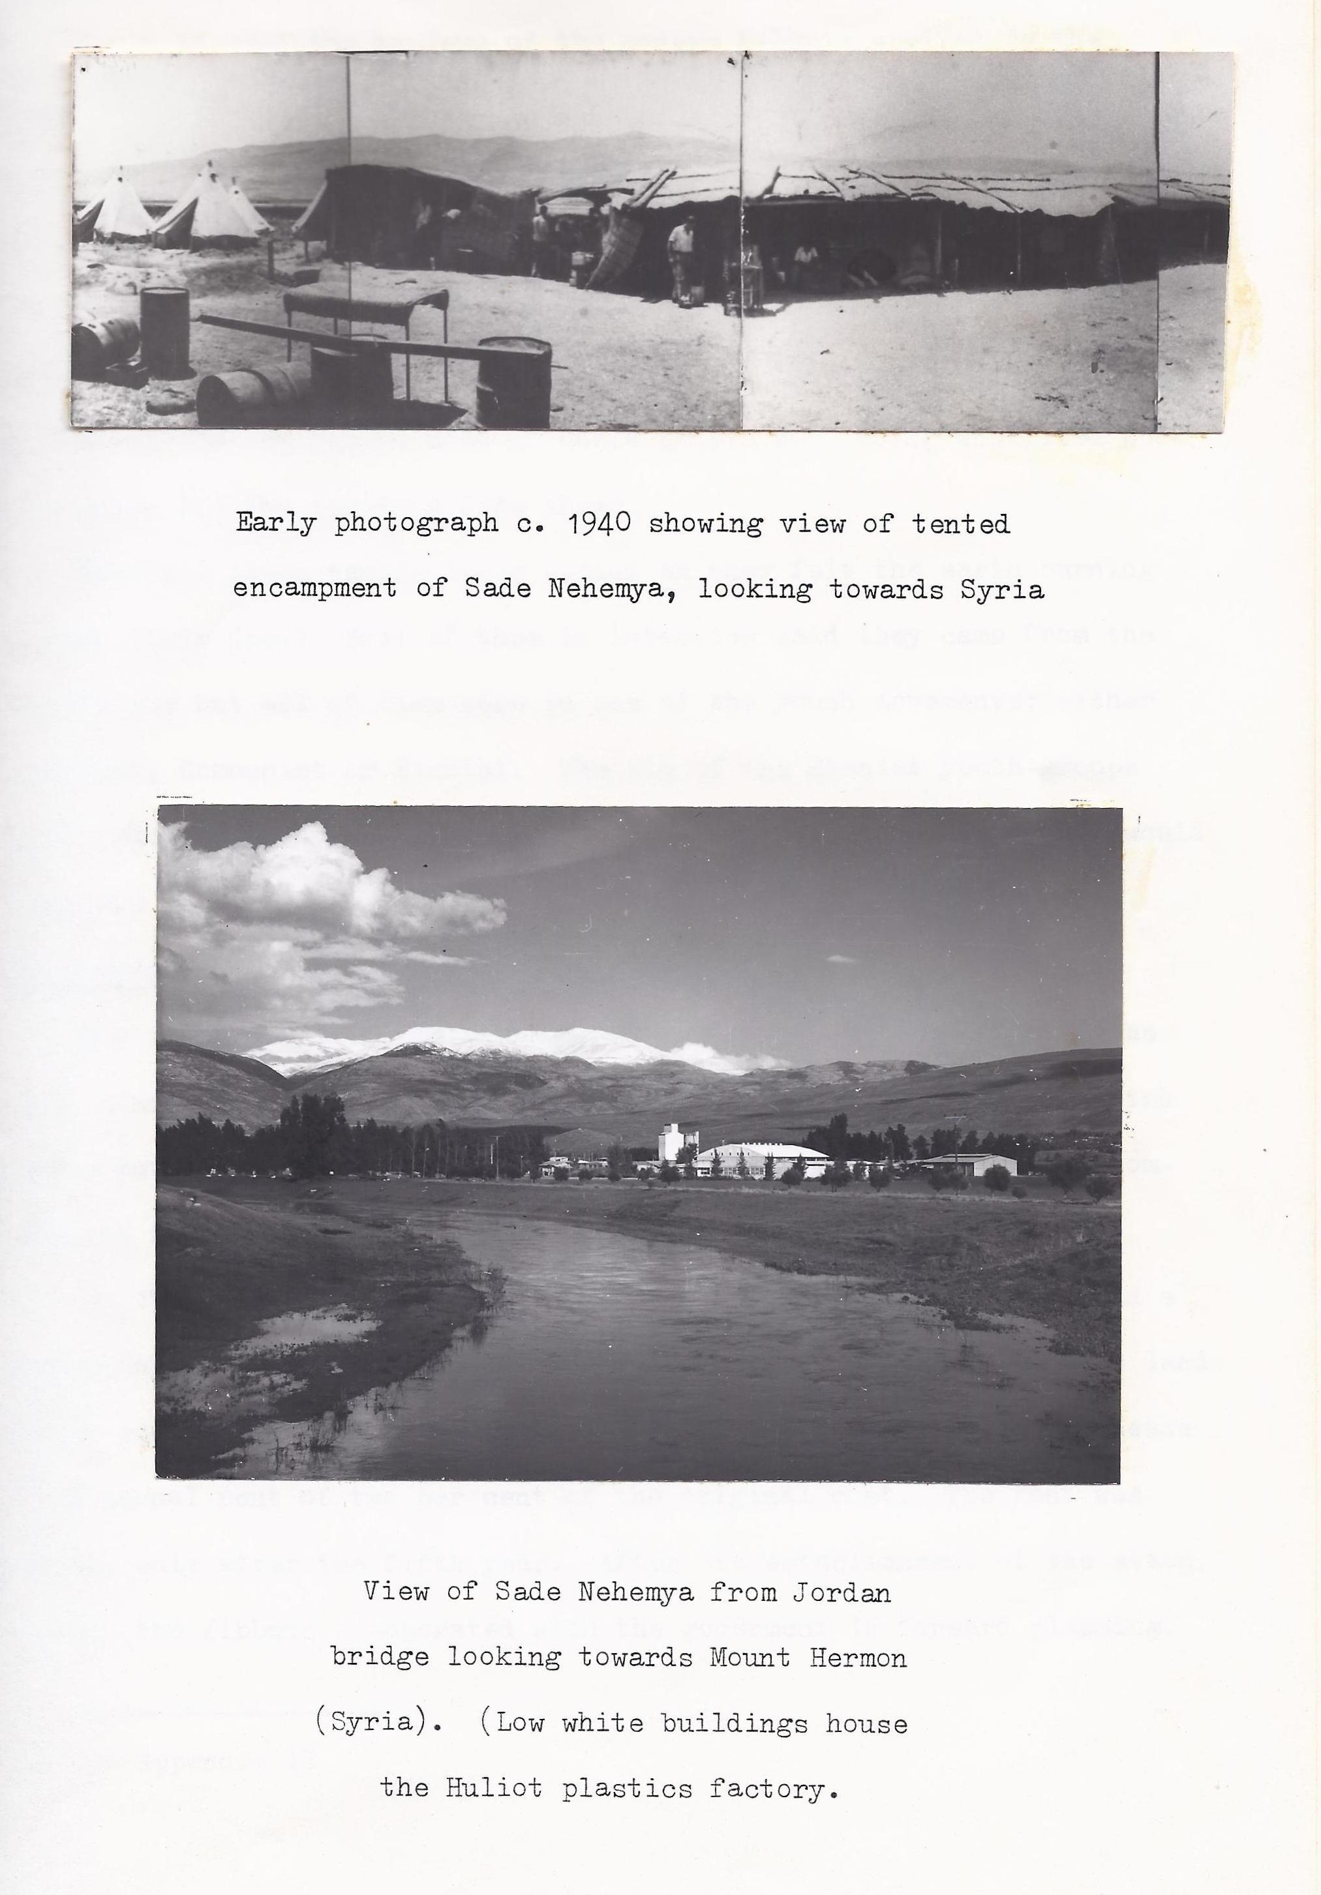

Early in 1941 the nucleus of the modern Kibbutz arrived in the shape of Zionist groups from Holland and Austria. The Czechs merged with the others making about one hundred members in all. The German Jews arrived with the Dutch group since they had already left Germany in 1933 for the healthier climate in Holland. All the original members had left Europe by 1939 except some of the Czechs who came as late as 1941. In the intervening period most of these people were doing unskilled work to prepare for the rigorous life ahead.

What did these people leave behind as they felt the earth burning beneath their feet? Most of them in interview said they came from the bourgeoisie but all of them were in one of the youth movements; either Socialist, Communist or Zionist. The aim of the Zionist youth groups was to educate Jewish young people in Zionist thinking so that they would then help to establish the Jewish state in Palestine.

The development of the Kibbutz1

The first stage of development was concerned with building up the

farm, planting orchards, preparing fields for irrigation, building fish ponds, putting up the children's houses and providing very basic accommodations for the members.

By 1948 there were 120 family units, a laundry, clothes store and a mechanical workshop. The Jewish Agency, in the meantime, bought the land and in common with other Kibbutzim leased it on a ninety-nine year lease at an annual rent off two per cent of the original cost. The rent was payable only after the fifth year. After the establishment of the state (1948) the Kibbutz co-operated with the government in forward planning.

In the consolidation period between the fifties and early sixties a plastics factory was established, equipment was improved and some accounts was taken of the need for sedentary jobs.

--------------------------------------------------------------------------------------------

1. See Appendix II

Expansion of the Kibbutz

A third stage is discernible in the late sixties when there was a great expansion services and a rise in living standards. There was a consequent improvement in educational facilities and an increasing number of young people going into higher education from Sade Nehemya. In 1967 the six day war was closely followed by a large numbers of volunteer groups from all over the world. I was in the first volunteer group which came from North London. It consisted of a Zionist youth group, 'Young Children of Zion" and myself.

I knew some Jewish friends who had been mobilized to support what they regarded as their 'homeland'. It seemed a good cause to take up since Israel was being attacked from all sides. I did not know what I would be doing by volunteering but in common with the others I was enthusiastic to go. We arrived after the war had finished and were sent to work on this particular Kibbutz. I was surprised at meeting a social system entirely different to any I had known. I was impressed because it was quite deliberately set up to be egalitarian and it worked, as far as I could see.

At least two Kibbutzniks told me that this was turning point because it was the first time that the outside world had actually entered their community. Since that time many of the young people of the Kibbutz have left to see for themselves what Europe and America have to offer.

Everyone realized that Sade Nehemya was not the center of the world. How to keep the young people on the Kibbutz is one of the most pressing contemporary problems for Kibbutzim.

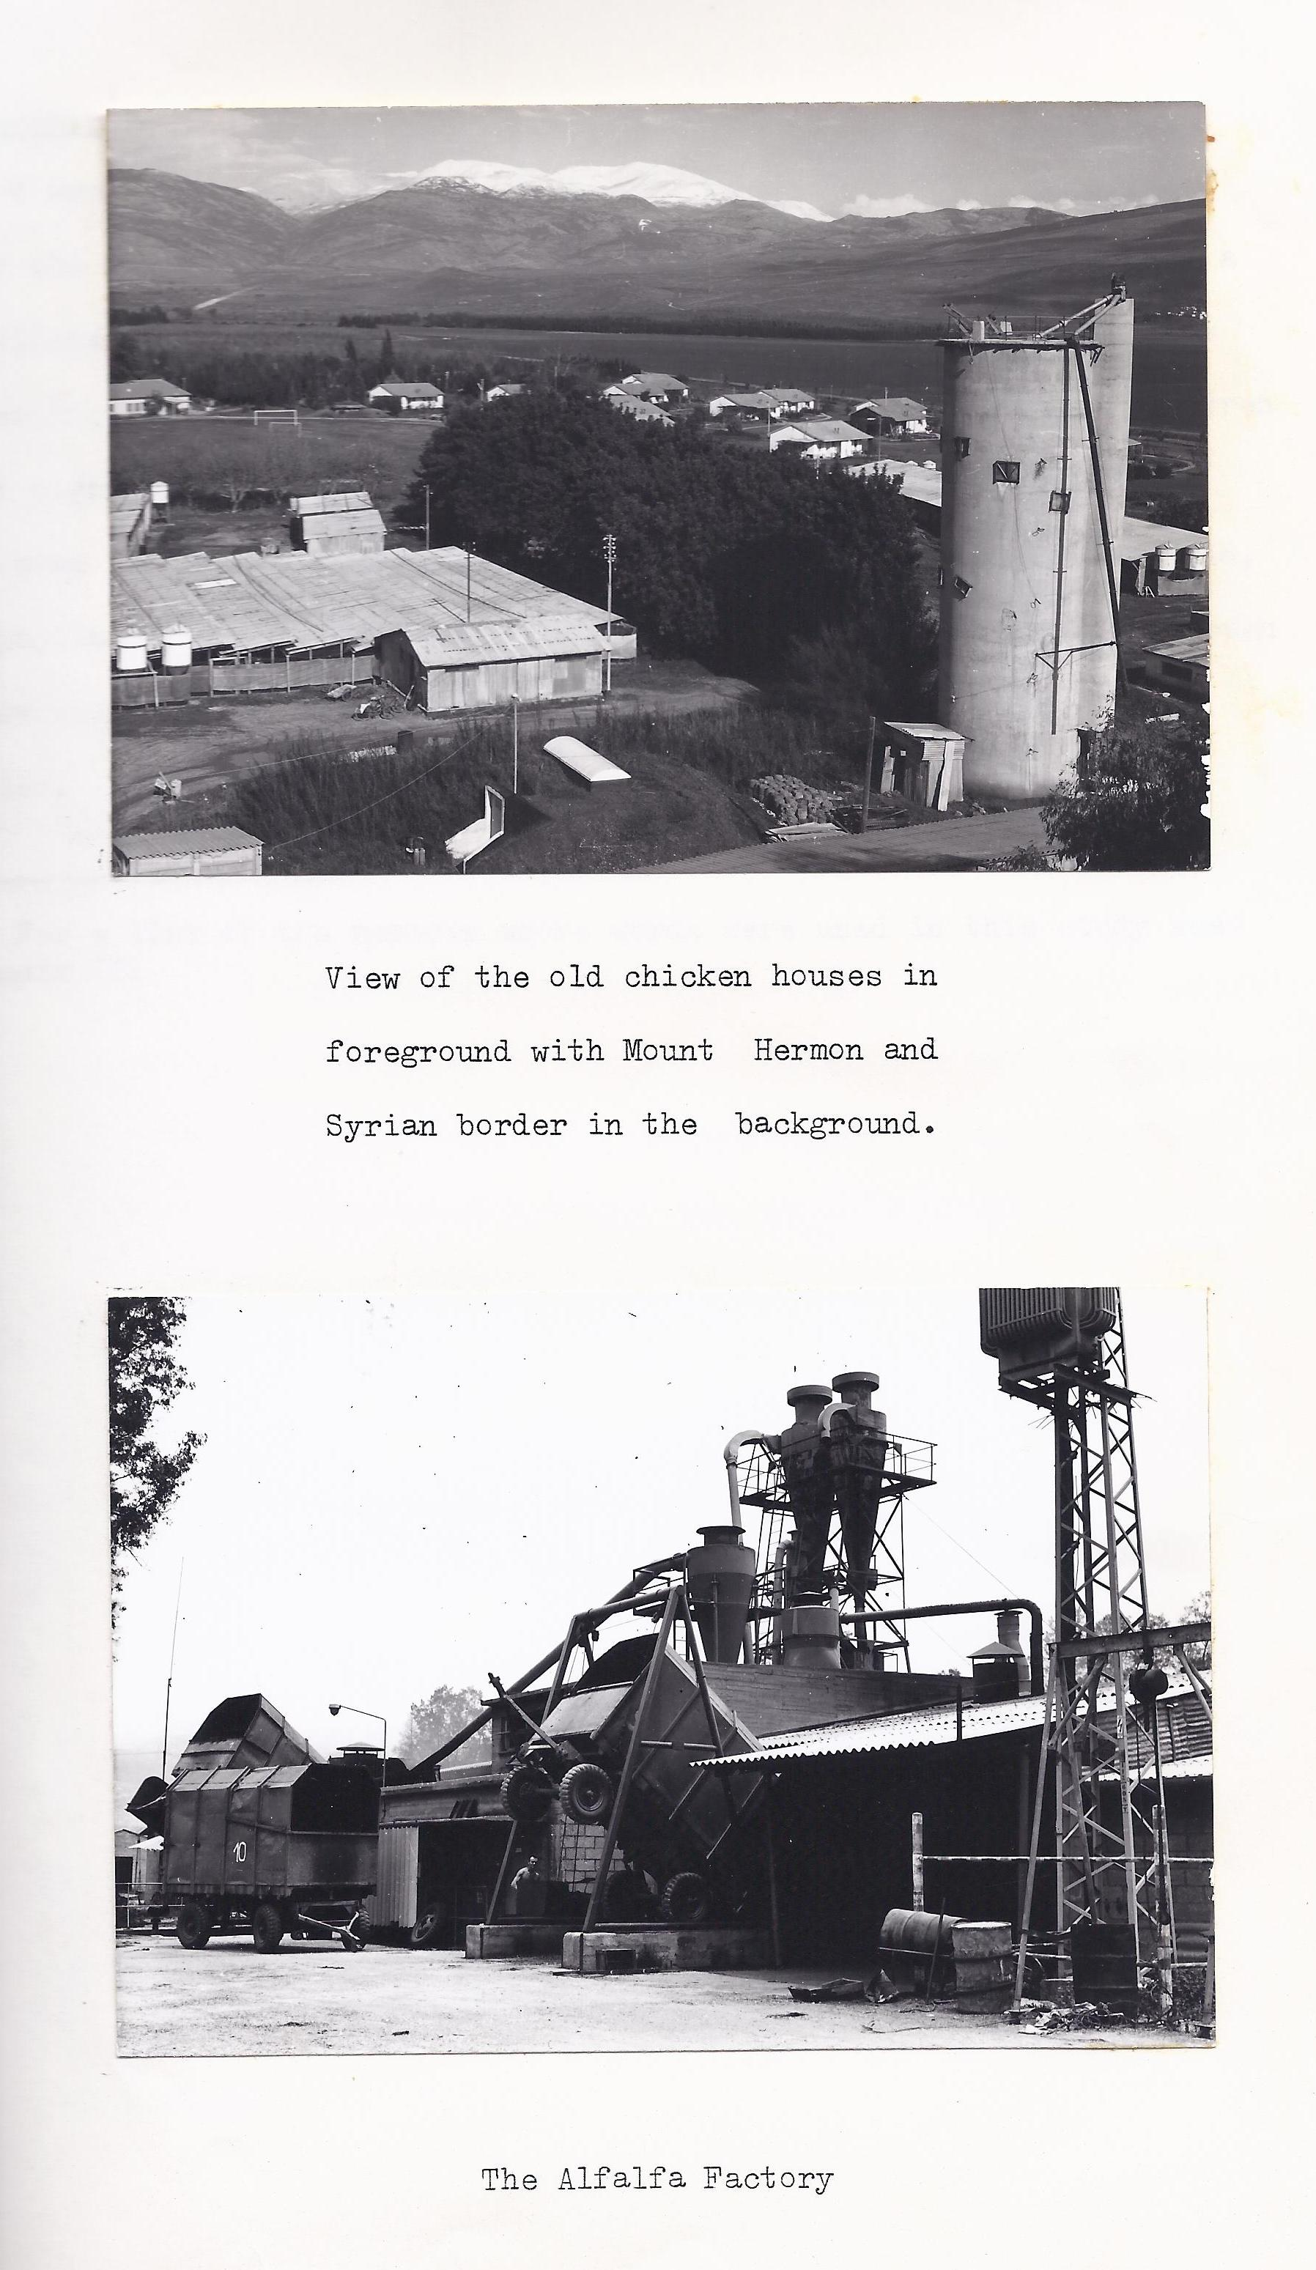

**Membership**1

A member of the Kibbutz will be over eighteen years of age and if he or she was not born there they would have to spend two years being a

'candidate', before being voted on, at a Kibbutz meeting. The present membership of this Kibbutz stands at 191. Add to this the about 200 children under eighteen and about 30 other non-members and it is possible to have some idea of the size of Sade Nehemya. For many years, I was told, the population was at a constant 130 members, but then it had always been a 'Kevutzah' rather than a Kibbutz, which meant that it was always smaller

1. For a list of the members whose words were used in this study see Appendix III

**Chapter II**

**METHOD OF INVESTIGATION**

The question which intrigued me was how the Kibbutz had changed in the way it did. In order to find out how, I designed a questionnaire to provide what I regarded as essential information. Although I knew what

Sade Nehemya was like in 1979, I was not in a position to explain how the Kibbutz had changed since 1940. I had to rely on the members whose experience spanned forty years.

The secretary of the Kibbutz (the 'maskir' Uri *Goren*), gave me a short history and Chetvah *Peled*, the head teacher of the school set down the children's original daily routine. In discussion with her I was able to amend my questionnaire. I ended up with sixteen questions1 which I put to thirty people. I included questions on country of origin and the reason for leaving it. The founders were very similar in their backgrounds2 and I was fascinated by the stories I heard. It was unfortunate that one tape-cassette was lost and so this study is based on the answers of twenty-four respondents.

It seemed that the study should reflect the different groups which were connected with the changing life of the Kibbutz. It would be expected that the answers of the founders would be different to those

of the first generation, for instance. Therefore I included representatives

of the three discernible groups of members. I set out below the details of the sample based on the current size of each group now living in the Kibbutz.

1. See Appendix I
2. See Appendix II

members members in my sample

Founders/veterans 61 6

First generation 58 7

(born on the Kibbutz)

Late comers to the Kibbutz 73 11

(Those who arrived after 1948)

Total 192 24

Young people under eighteen were not the subject of this study because they were not considered as members by the rules of the Kibbutz. Only after national service are they asked to make a decision about becoming a member. Until that time they enjoy the life of the Kibbutz without voting rights in much the same way as we do in this country. I was able to talk to a small number of fourteen to sixteen year

olds through an interpreter. What they said was very interesting but was not entirely relevant to this study.

My original intention was to use the answers to my questions as the basis of my study. After the accumulation of data, which took a large number of evening taping sessions, I found I had to much information. Most of it was interesting material but I realized it made the task even more difficult. I spent several days transcribing what appeared to be relevant. I ended up with a wad of notes that I could not bring any sense of order to. I had asked to many questions, it seems. Not only that, but the way in which I could make sense of it eluded me for some time. It was only by talking to friends from other disciplines that I came to several different views of the work as a whole.

I did not want to discard the original intention of using the actual word of the Kibbutzniks. I took a lot of trouble to record them and anyway that aspect was always important to me. I wanted to look in depth at the way in which child care changed so radically. I limited my study to the only Kibbutz I knew. I expected my work to differ from other work in this field because I was interested in the quality and direction of change. 'Experience is the highest authority' wrote Carl Rogers1 (1967) and I thought I would like to uphold that concept in this study.

1. Rogers, C. ( 1967) On Becoming A Person Constable, London.

I used the words of the Kibbutzniks because I felt sure that they knew the answers to the questions I was putting. I wanted to see in what way their experience differed and whether that differing experience could lead them to different conclusions.

When I listened to the vast body of opinion and fact contained in

the tapes I realized that it would have been better to have asked some

different questions which I did not actually as my informants. Whilst this may sound dubious I hope the reason for so doing are not difficult to understand. The questions below, I suggest, did indeed improve the organization of my answer.

1. a) What was the Kibbutz like originally?

b) Why didn't the founders have children sleeping at home?

2. What was life like for the children born on the Kibbutz and

who grew up in the children's house system?

1. Why did it change?
2. Did it improve life on the Kibbutz?
3. Who changed the arrangements?
4. How will the Kibbutz develop?

**Chapter lll**

**WHAT WAS THE KIBBUTZ LIKE ORIGINALLY?**

What did the pioneers find when they decided to set up a settlement in the Upper Galilee in late 1940? Armed with idealism and little else the sight of the Huleh swamp which once dominated the northern Jordan valley must have been strength sapping. It was a malarial breeding ground. The people had to contend, not only with that, but with breaking in the ground for agricultural purposes.

*We had to have our children living in the children's house because we had very bad conditions. We lived in tents or in wooden shacks; two families together. It was just a necessity. There was no possibility of parents having their children with them. My own two children had to be*

*with me because there was no room in the children's house at the time.*

*It may seem absurd now but I was happy to be able to put my children in the children's house. When my third child was born I had better conditions and kept my baby at home for six weeks. It was a pleasure.*

*(Lisa Gidron) 1*

Chetvah told me that the houses were very simple with no hot water. Precautions against malaria were very rigorous in these early days and as far as she remembered no children contracted the disease.

The children's house was constructed of concrete with screens at the windows. Every child slept beneath a mosquito net. When the children went out they were covered completely from toe to neck. They wore clothes with elastic cuffs. There was even a rule at this time which was designed to avoid children being exposed to malaria and other diseases. It was that no children under the age of three were allowed out of the Kibbutz. Leon (1969)2 writes that 'The settlers were exposed to frightful physical dangers in the early years, facing the pains of acclimatiisation to back-breaking agricultural labour in the

1. For the appraisal of the backgrounds of informants see Appendix II
2. Leon, D. (1969) The Kibbutz, A New Way of Life' Pergamon Press London. P. 11

Unaccustomed climate and landscape of the new country.' I think the evidence above goes some way toward refuting the pronouncement of Diamond 1 (1957) that '…They did not think themselves worthy of rearing (their) children within the confines of their own nuclear families and they dared not trust themselves with the task.' Some of the founding women would seem to think otherwise:

We wanted our children at home deep in our hearts but were afraid to speak out because we were Chalutzim.2 We were very lonely and we married early.

(Yehudit)

Many women wanted their children at home but there was no way to do it.

(Ruth)

I prefer to think along with Weingarten3(1955) that, 'This system,

at first merely a pragmatic arrangement… has assumed the flesh and blood of a very definite educational philosophy(because) the purpose of the Kibbutz is not only…. to set up a new economic framework for society (but) to create a new man.' Infield4 (1944) too, makes the same point: 'Basically, what shaped its character was the necessity for adaption to the unusual conditions obtaining in Palestine. Hence, the peculiar social structure was necessary to ensure survival.' Joseph Baratz5 (1954), writing about Dagania the very first Kibbutz of its kind says much the same thing:

*When the first child was born in the Kibbutz nobody knew what to do with him. The women did not know how to look after babies. Evenually a house was put aside where the children could spend the day whilst their mothers worked. And so this system developed and was afterwards adopted in all the Kibbutzim*.

1. Diamond, S. (1957) 'The Kibbutz: Utopia in Crisis' Dissent IV p. 134

2. Chalutzim means pioneers.

3. Weingarten, M. (1955) Life in Kibbutz (New York Reconstructionist Press.) p. 21

4. Infield, H. F. (1944) Co-operative Living in Palestine (Dryden, New York) p. 25

5. Baratz, J. (1954) A Village by The Jordan (Harvill Press, London)

There exists a very neat encapsulement of these ideas propounded by Berger and Luckman1 (1967). The social construction of reality theory argues that the original rules of society are based on necessity. The necessity then becomes part of the growing ideology and becomes institutionalized. The communal rearing of children was for many Kibbutzniks the very element which differentiated Kibbutz life from all other forms. When privation was norm, the Kibbutzniks were prepared to forgo self-interest.

1. Berger, J. and Luckman, T. (1967) Social Construction of Reality (Allen Lane, London)

**Chapter IV**

**WHAT WAS IT LIKE LIVING IN THE CHILDREN'S HOUSE UNDER THE OLD SYSTEM?**

1. Hard Times

The second generation were not only very responsive to this question but in some cases quite moving and even eloquent.

*When I was small it was very hard. The metaplelet1 wanted to sit on our heads. We had to be good children all the time. We couldn't*

*have fun. They felt something was wrong and needed changing. The first metaplot2 did not understand children. Parents wanted to be good Kibbutzniks and they didn't know how to do it together with being good parents.*

*I was very frightened as a child. I remember nights spent at the window of the children's house just to see if anyone passed. I felt alone, even with other children. When the first children of the Kibbutz started to grow up they felt it had to change.*

*(Hannah)*

*The depressed feelings evoked in Hannah's account are reflected again by Aldat:*

*We spent so much time with each other as children that we could not reveal any personal feelings or weakness to others. This was endangering our existence in that society.*

*(Aldat)*

*This picture of authoritarian rigidity on the part of the metapelet is enhanced by others.*

*In the early days discipline was to strong. During my childhood it changed. It got softer. I remember very soft nurses who didn't fit the system then. I don't remember much before ten years of age.*

*(Mikhail)*

1. Children's nurse / educator.
2. Metaplot – plural of mataplet

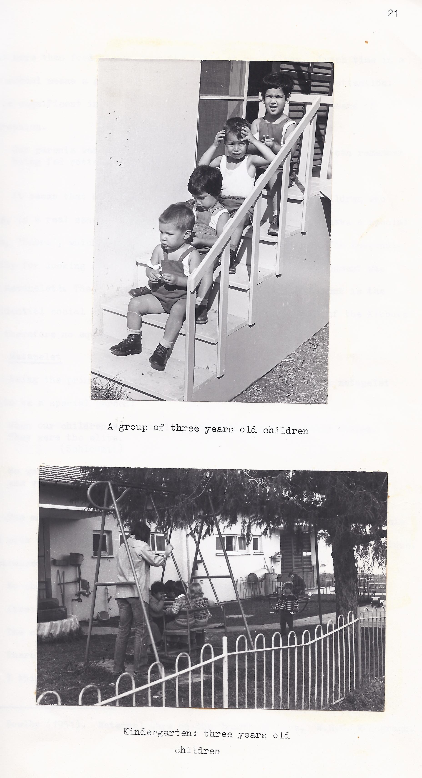

*When I was a child it was stiff. Now the education system is more free….We were force to eat. We could sit ten hours but we had to eat. The egg of the morning can be the egg of the lunch and of the dinner.*

*(Yael)*

*I do not find it surprising that food is mentioned in such emotive terms. Experience with maladjusted and my own children leads me to believe that more than food passes over the table at meal time. Lunch time in a day school means a great deal in terms of providing care and attention. It is significant in my opinion that food is felt here as a means of repression.*

*Our parents wanted children to be as tough as nails. I can remember being fed rotten food, but we had to eat it.*

*(Aldat)*

It seems that hard times were brought to bear on the children who were, in a real sense, a 'new' breed of people. They even have a special name, 'Sabra', which means a pear: of the prickly variety. The responsibility for looking after the children under this harsh environment was the metapelet's The closest I can get to its British equivalent is the residential social worker. There exists for us no equivalent of the Kibbutz and therefore no equivalent metapelet.

1. Metapelet

Being the principle care-giver the person chosen to be a metapelet

had to be a special person:

*When our children were small the metapelet was specially chosen. They were the elite.*

*(Schloomit)*

*We were more together then. It was a closed world. The metapelet was very important; like a mother.*

*(Rachel)*

The metapelet was responsible for all the major tasks usually associated with motherhood which Bowlby1 (1951) thought to be specially pernicious. He stressed three factors:

1. No chance to form a close relationship with a mother figure in the first three years of life.
2. The child was maternally deprived for limited periods.
3. There was inconsistency of handling.

I think, historically speaking, these views have been surpassed by the experience of Kibbutzniks who have grown up and shown the doubters that they are not unattached or unemotional freaks born of a sterile culture. The metapelet, in fact, was only the instrument by which the Kibbutz carried out its policy. She was invested with a great deal of power and used it:

*It was very strict. Parents were not allowed to see their children except at certain times. The mother was allowed to feed the baby not one minute before and not one minute after. In the morning children went to their parent's house for two hours. They ate there and the metapelet put them to bed. Later, parents put them to bed. Even then the metapelet came the last five minutes and to turn off the light.*

*Babies were not allowed to be taken out of the baby house for the first three months. The mother spent one hour of the working day with the baby. The father had to peep through the window.*

*At six months if your baby was still breast-feeding you were lucky.*

*If not, he had to start eating from a spoon.*

*One mother started to shout against it. She gave up.*

*Schedules were arranged by Kibbutz committees. Parents were very small things in the matter. It was remarkable that even in these two hours a day the children grew exactly like their parents.*

*(Nomi A)*

It is difficult to imagine people subjecting their children to such a regime today. Gerson2 (1974) pointed out how things had changed for the better when parents' status was enhanced. They had by then begun to take a more active role in their children's education.

1. Bowlby ( 1951) Maternal Care on the Growth of Love, W.H.C. Monograph
2. Gerson, M. (1974) The Family in the Kibbutz ( J. Child Psychol. Phychiat. ) Vol. 15 p. 47-57
3. The peer group

Because the first children of the Kibbutz were brought up together, separated from their parents at night it seems that just

as some were depressed others,notably boys, felt it to be a good way of life. Contrast the two following passages from people of

approximately the same generation who experienced, differently, the same regime:

*We have a saying; 'In the early days children were the limbs of the Kibbutz.' There was a very good friendship at the time…..I liked very much to be in the children's house. I had to sleep in the dark. I did have some conflict with other children about this. Other*

*Children were satisfied with the children's house I don't remember others having night difficulties.*

*(Mikhail)*

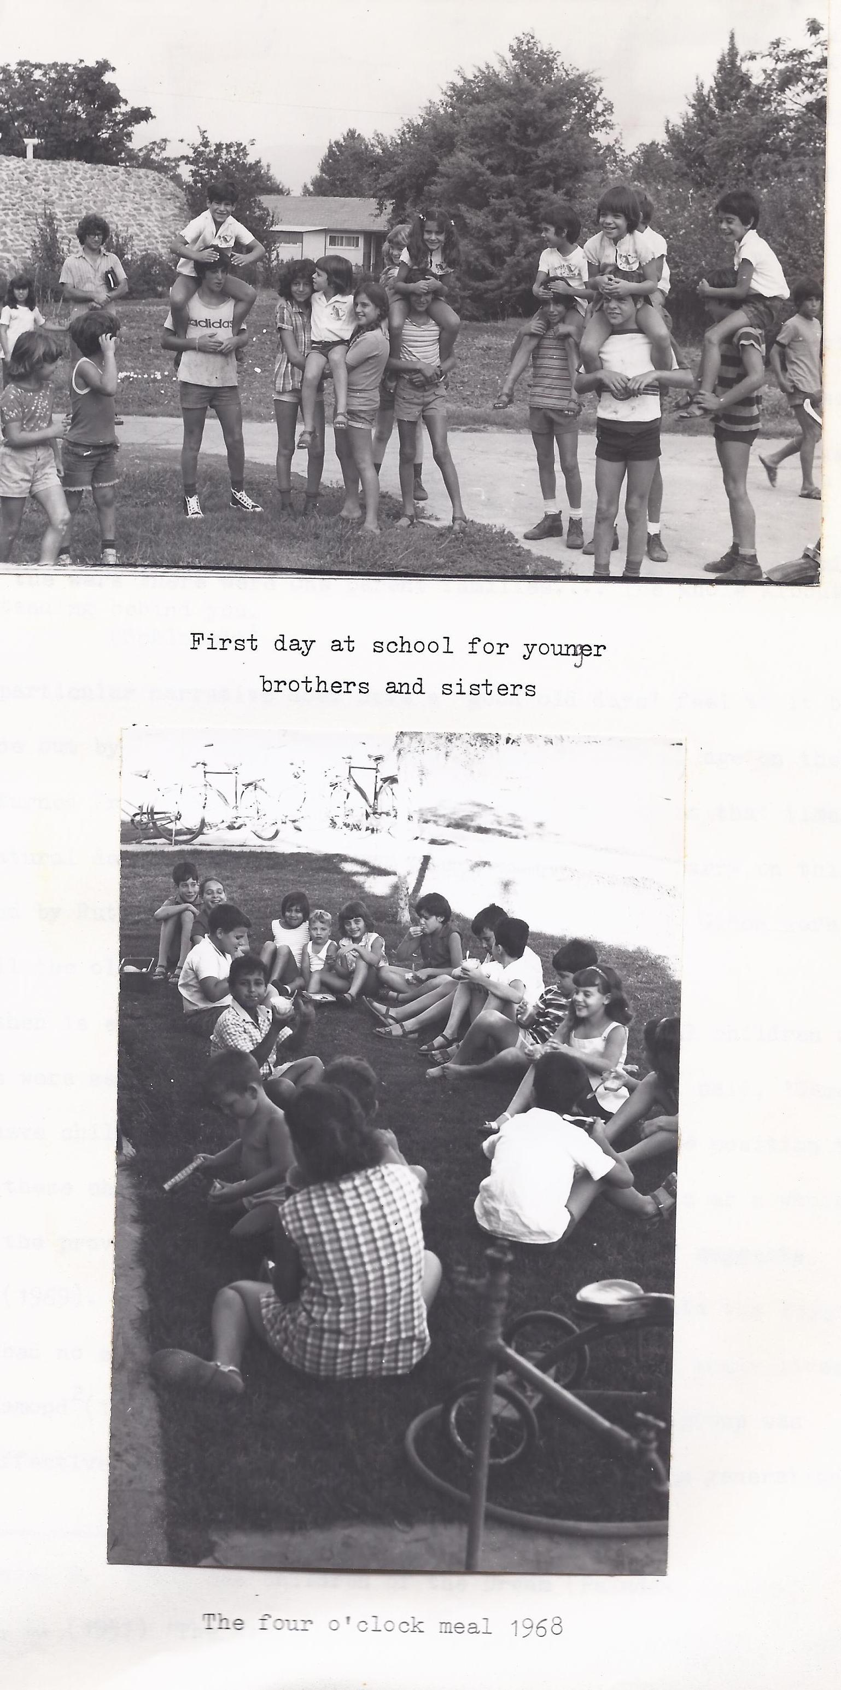

*When I was small the education committee decided that you could sleep at home when you were sick or had nightmares. Sometimes I was sick just to sleep at home. The parents were too weak against this rule.*

*I hated sleeping in the children's house. I remember nights like it happened yesterday when I was so miserable in the children's house. I was always trying to sleep at home. I was terrified at night.*

*(Nomi A)*

It would be indefensible to deny either as untrue but perhaps an overview from one of their parents' generation might put it in perspective:

*My children were bound together more than by grandchildren because they ate and slept together and there was not so much outside influence at this time. Our children had a much richer life. They were much more self-reliant. For example, the first four or five groups who went through the army, on the whole returned to take up positions of responsibility…. Life was harder but I think the children were happier. They adjusted better to things in the family. After the wars there were one parent families…. The whole Kibbutz was standing behind you.*

*(Schloomit)*

This particular narrative does have a 'good old days' feel to it but she is borne out by Uri, 'Most of the first class to come of age on the Kibbutz returned from the army to stay.' By Achi, 'For us, at that time, it was a natural decision to return because someone had to carry on this place.' and by Ruth, 'The first classes of Aldat, Micky and Gidon were known by all the older people.'

Here then is evidence of a well known fact; the original children of the Kibbutz were seen to be very special people. As Mikhail said, 'Remember, we did not have children older than us.'

This was a remarkable position to be in. To these children 'in an emotional sense, the Kibbutz as a whole stands for the providing, controlling and educating parent,' suggests Bettelheim1(1969). Like their parents who founded the Kibbutz the first generation had no older brothers or sisters on whom to model their lives. Although Diamond2(1957) thought that being reared in a peer group was 'the most effective way to break the psychic link between the generations,' that clearly did not happen, if only because things changed.

Why things changed as they did forms the next part of this study. I hope all will be made clear by and by. I will continue to rely on the variegated experiences of my informants, who I might add, enjoyed answering questions.

1. Bettelheim, B. ( 1969) The children of the Dream ( Paladin, London)
2. Diamond, S. ( 1957) "The Kibbutz : Utopia in Crisis" Dissent IV p. 136

**Chapter V**

WHY DID CHILDREN'S SLEEPING ARRANGEMENTS CHANGE?

1. An account of how it Happened

*The problem of where the children slept was influenced by people from outside. Some of the wives of the members came from outside. Early on, those who wanted children sleeping at home were a minority.It brought bitterness and made the atmosphere clouded. Their voice got louder,I felt like the last Mohican. The committee that was looking into it was divided equally. We went to other Kibbutzim to see how it worked. We knew that Gonen had children at home from the beginning. We could see it was very good.*

*Some people at the end did what they wanted. The establishment was too weak to resist. The years 1971 and 1972 many people tried to forget. We knew the price for not changing would be the departure of these wives with their husbands. We were afraid of this 'domino effect! 'This development ended in the summer of 1973. We said 'For home peace we will change. The Kibbutz is not built on children sleeping at home.'*

*(Mikhail)*

Mikhail's story leaves out a number of issues which I will take up later. It does nevertheless give a subjective impression of a process of change. He was one of the original children who returned after the army to take up his rightful place in the Kibbutz.

Changing what he thought was a worthwhile system must have felt like negating all he had been through.

In the end it seems, the difficulties obstructing the change were put aside. Here again, the founders who had struggled to fix Sade

Nehemya on the map now saw their ideals swept aside, or so some of them thought, by their own children.

*The first laws of the Kibbutz came from the life of the Kibbutz which depended on the very primitive conditions at the time. To change the sleeping arrangements was very difficult because every step gave members the feeling that they were destroying the Kibbutz.*

*(Ruth)*

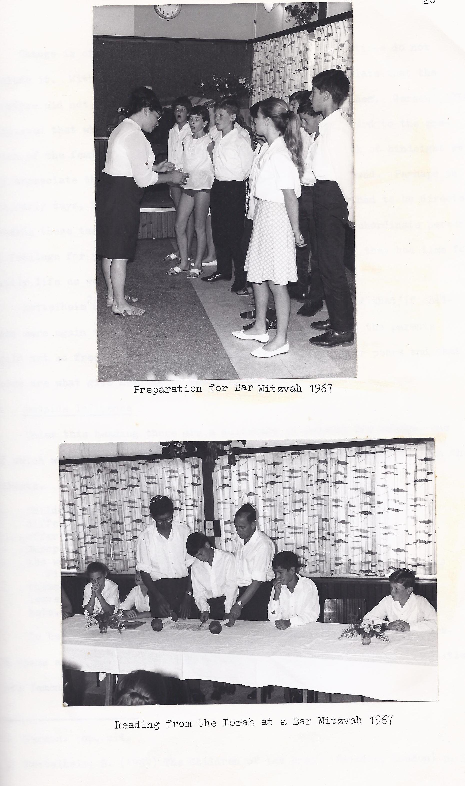

'Destroying,' in this context relates to the founders' ideals.

Another explanation talks of 'wounding',

*The change came about because life was a little bit artificial.*

*There were rules about what children wore, what time they ate*

*And what time they went to bed.*

*In many ways this change was no good for the life of the Kibbutz. The main meaning of life here was wounded a bit by this change*

*(Nomi G)*

Change is often difficult, especially if your expectations do not include it. With no precedents to follow I can only speculate

that the founders did not conceive of change in the way it befell them. Gerson1(1974) suggested that what he calls 'this extremist outlook in regard to the position of the family' would have to change. Given the trick of hindsight we can appreciate the inevitalility of the changes that followed. Perhaps in the early days, there was only work and survival. Energy had to be directed towards these tasks and all Kibbutzniks were prepared to subordinate personal feelings for the sake of the communal good. I doubt if they had time for family life as we know it in the west.

Bettelheim2(1969) reported that he was repeatedly told that' if children were again to live and sleep with their parents, then the parents could not so freely be part of the doings of their peers and that these are what give meaning to their lives.'

2. Outside Influence

Under this heading there are a multitude of reasons for change, one of which was mentioned by Mikhail; the influence of people from outside the Kibbutz. It is remembered by one of the founders this way:

*Child-rearing changed as much from outside influences and from different people who came to the Kibbutz who had other things to offer*.

1. Gerson. Op. cit.
2. Bettelheim, B. ( 1969) The Children of the Dream ( Paladin, London) p. 35

*In the beginning we were people from almost the same European background. After 1948-50 came people from all over the world. They brought other problems.*

*First they didn't have the motivation to sacrifice something of themselves. They didn't have it. They came because they had to leave Europe or the Islam lands. They were not necessarily Zionists. We had a lot of problems with them.*

To be fair to Schloomit she did talk about other important factors.

It seems as though she is referring to the advent of the Jewish communities from Yemen, Iraq, Iran and North Africa. Mikhail remembers that time:

*In 1951 a youth group came. It was our first meeting with*

*children. I remember feeling a very big inside war to make friendship with them. There was something also of race in it.*

Rachel was one of that group. The Kibbutzim were expected to help in coping with the vast influx of Jews at the time and in particular to deal with many children without parents. Large-scale 'fostering' would only have been possible in such a place as the Kibbutz. Schloomit continues with a much-quoted reason:

*On reason for the change was the security problem. Before the war we couldn't leave the children anywhere. They were concentrated in the children's house. That was so even in the 1967 and 1973.*

*The Kibbutz was always a defensive out post and in the far north of Israel; Sade Nehemya would be expected to fight for itself in the event of attack. The interruptions of war must have had its effect on parents and especially the children.*

*The change began in the seventies. Terrorists were attacking Kiryat Shemona with rockets every night. The children were afraid. I was on guard duty at the time, three nights in a row*

*And I remember the screams of the children. The night nurse had a microphone and she was constantly trying to comfort the children. I should say the fact of being bombed was a catalyzer for the change.*

*(Dov)*

Better reasons for changing the sleeping arrangements I have not heard. During the Yom Kippur war (1973) the children were in the bunkers for six weeks. When it was over the parents took them home. However,the security problem only sought to underline

an already serious situation.

Accordingly,

*Another reason for the change was the daily and nightly parting of children and parents. To bring a child to bed with another fifteen pairs of parents and fifteen screaming children wasn't very nice.*

*(Schloomit)*

A young man of the first generation saw it the same way almost:

*Children's sleeping at home was not a philosophical change. It took place because of difficulties in putting children to bed in different places. It was thought to be more convenient to put them to sleep at home. It was an economic change and not a radical one because the bond with the parents has not changed much.*

*(Aldad)*

Before I leave the subject of outside influence, I would like to turn to one of the male founders who, on the whole, I found to be unlike their womenfolk, quite laconic:

*There has been no great change in child-rearing in the Kibbutz. There have been changes throughout Israel. And therefore in the Kibbutz. Once, the country was more idealistic and now it is materialistic.*

*(Avram)*

All things change, in other word. Perhaps also, Avram wanted to

Blame the outside world, a strategy that may seem very attractive to a system that has changed direction against the wishes of its originators. Inevitably, change would come, of course:

*We were more secluded then and because of this it was easier to raise children according to a certain way. It was difficult to keep immune from the urban culture (of Israel). Everyone has to go in the army and our children could not remain aloof from this urban society.*

*(Dahliah)*

I acknowledge that Kibbutzim must have been influenced by conditions obtaining in the State of Israel. However, to what extent urban society impinged on Sade Nehemya is not within the scope of this dissertation.

1. Changing is difficult

*The change was for twenty-five years a very hard problem. Five or*

*Six families left because the rule was not changed. Men members*

*thought it was not possible. Many women wanted it but there was no way to do it. In the end only three or four young families were against it.*

*(Ruth)*

There are those on the Kibbutz who wish the change had not taken place and I can only imagine the kind of debate that must have occurred at the weekly meeting. In a novel by Banks1(1962) there is reference to the heat engendered between Kibbutzniks:

Wilfred…..was forever pressing for reforms, like allowing children to sleep at their parents' homes…..Moshe used to conclude ferocious arguments with Wilfred…shouting 'Tov, good, fine, vote for it then, let's call a committee meeting and you can vote for it- but by God if we ever have it here, all I can say it's the end of the Kibbutz movement and I shall leave and become a bloody rov! '

I found change, a subject of enduring interest because, it seems,the

ability to change is tantamount to growth and that 'no change' is a sign of 'death' or stagnation. This remarkable discovery took me years to come to in my own life and I found the descriptions of the

Kibbutzniks very enlightening, therefore,

1. Banks, L. R. ( 1962) An End To Running ( Penguin, London)

*The secret of our survival that we are always in movement.*

*Kibbutzim are the only communes that are not closed from the*

*outside world. We do not resist change. When we stay in one*

*place the Kibbutz will end.*

*(Mikhail)*

There is an implication in work with maladjusted children that there will be change. The reasons why children are referred to special units or child guidance clinics are to be found in their inability to make adaptations in their behavior. It is precisely this ability to change and adapt to new situations which is lacking in the neurotic character. Unless such children can become aware of their difficulties there can be no change for them. They tend to continue with the same maladaptive behavior which only serves to keep out of consciousness the necessity of change.

Whilst these children would accept that they do not feel very happy about their situation in school they are afraid to try an alternative way of behaving because they do not know what might happen. The unknown holds great fear for them. I see the task of teaching children of this inclination to be one of reflection. What I mean by this is that the teacher, as a mirror, reflects back to the child the way he is behaving. In this way it may be possible for the child to become aware of his inappropriate behavior. Readiness to accept the need for change is the next stage but cannot be achieved without the painful process of awareness. The teacher's role, I see, as that of 'enabler', someone who is at hand to assist the individual in his bid to be free of self-defeating archaic concerns that block personal development. But, as Uri says, *'Changes were not made just like that. Things are changing all the time.'*

The Kibbutz too, has had to adapt to new situations and although some would say that it has changed out of all recognition the fact is that the Kibbutzim still exist and appear to have the determination to continue to exist whatever the political or economic climate.

1. Financial considerations

Once a change has been decided, then the next stage is to put it into

practice.

*After deciding to change it took three years to build the right sized homes. It took altogether ten to eleven years to inplement fully.*

*(Schloomit)*

*One result was that the standard of living was lowered. We were overcrowled before the extra room was build. This led to some people leaving…..I don't think it could have worked out differently.*

*(Mikhail)*

Conditions, by all accounts, were made worse because there was never sufficient money to carry out the kind of building program

that would have made family life possible. Some Kibbutzim, like Degania, always had children at home but they grown that way and were not subject to the same internal conflict at Sade Nehemya. The

Kibbutz federation was interested in keeping building standards high,

by all accounts:

*It was eventually decided that if the Kibbutz was rich enough to build an extra room then it could happen. The Kibbutz organization, Ichud, told us they didn't want slums on the Kibbutz!*

*(Lisa)*

How frustrating it must have been to have spent years asking to have your children at home and then to be present when the rule was changed, only to realize that in order to make it work, time and money would be the governing factors. When I visited in 1979 I worked on some new buildings, one of which was a club-house for the teenagers. Close by were some very new houses which already had two or three bedrooms. All houses now have the extra rooms.

Teenagers; that is from the age of thirteen or fourteen, have their

own housing together. They live in small units with shared facilities.

Teenagers were excluded from the altered sleeping arrangements. No-one I spoke to even hinted at the idea of them sleeping at home.

No doubt some do occasionally but it seems that the present system is seen by all to be the best.

1. Who wanted to change the rules?

The options for answering this question are not limitless. It does not seem possible that the founder generation would want to change their

system because they talked in terms of 'destroying' the Kibbutz by such

changes. The only discernible group who seemed to have some reason for changing were those who had grown up in it. Here are some of their

answers:

*Those who were for this change were parents of a certain age group. They didn't want to give up (the idea) and they were strong enough to change it. It took a bit more guts to take the first step. You have to have courage. A group of parents used to sit together and talk about the problem.*

*(Nomi A)*

*Maybe it's the young people who grew up here, who didn't want it for their children.*

*(Yael)*

*Mostly the push was made by women. The husband only had to agree.*

*(Gidon)*

*Children born on the Kibbutz, when they became parents, wanted more privacy and more responsibility for their children.*

*(Achi)*

*When the first children of the Kibbutz grew up they felt it had to change. They wanted to feel like parents.*

*(Hannah)*

I think Hannah is actually the most accurate. She says that they (the first generation) felt it had to change because they could not feel comfortable with themselves if they were not allowed to be parents.

*Now listen to the founding generation on who wanted the change:*

*No group or individual was responsible for the change. I think it is what happens in the rest of the country.*

*(Avram)*

*Most members wanted it. The people who didn't want it were the educators because they would lose their influence.*

*(Ruth)*

*Our sons and daughters were responsible. I remember mothers of my generation wanted children sleeping at home but for children of these mothers the question arose again. I don't know if it was bad memories of their childhood. The children didn't want to go from children's house to children's house. Some parents admitted sleeping with their children; it was always problematic.*

*(Lisa)*

The first answer appears to discount any internal Kibbutz reason for change. It was true that the rest of Israel has changed a great deal and that it will continue to influence the Kibbutz. It is also true that influence is two-way. I find it interesting that this defensive attitude appears to be particularly male. The two women seem to be much more realistic. The first sons and daughters grew up to demand and eventually to achieve a different sleeping system for them and their children.

Here are some other opinions:

*The people who lived in the children's house (in the past) were those that who wanted children at home. I heard they used to run away because they didn't like it.*

*(Aliah)*

*There was great pressure to change the system. There were people who didn't want it.*

*(Esther O)*

*These people were below the age of forty; between thirty-five and forty years old. The almost newly-married.*

*(Dov)*

*There was a strong pressure from the youngsters for this change.*

*(Magda)*

*It was a public decision. I cannot single out people. It was contrary to the material possibilities of the time. Talks were going on about it even twenty-five years ago.*

*(Daliah)*

*Lots of mothers wanted this change. Some selfish mothers saw an end to their freedom and didn't want it.*

*(Offrah)*

1. Discussions

In a sense it is true that the decision was a public one. Any change in

Kibbutz policy must be voted for by seventy-five per cent of the members.

It is not difficult to imagine the history of the issue for the Kibbutz. Originally there was only the thought in some of the women's head that they would have liked to have their children at home. Only when those children grew up did the pressure for a change slowly build up. The more the children grew up, the more vocal their protest became. Eventually, after some families had left, the older generation gave way. They gave way to their children of course. That must have been a strange feeling. I can think of no comparable decision in our culture. We can leave home and run our own lives if we choose. On the Kibbutz things can be changed by voting. Parents and their grown-up children can often be living under the same conditions but separately. They have equal say in changing those conditions.

One striking aspect of this situation was remarked upon by one of my informants:

*They (the children) see the father washing dishes or working in the fields. I have seen teenagers teaching their fathers a job. The father loses his image as a big man to his child.*

*(Dov)*

The first generation children may therefore have found changing the system to be less of an emotionally-charged desire than we might have done in our nuclear families. If children are sometimes in the position of

Teaching their parents then I can see that altering what their parents created would not be a terribly threatening task.

I would like to mention the work of Talmon1 (1972) who encapsulated this desire for antonomy by coining the concept of 'familistic tendencies.'

1. Talmon, Y. ( 1972) Family and Community in the Kibbutz. ( Harvard University Press, Cambridge, Mass)

These are characterised by a deliberate demand to increase autonomy for the individual family and to put the family before the Kibbutz. This idea was reflected by Joshua:

*…..The main change to sleeping at home came from the strong demand of the youngsters to be able to influence their children more.*

I don't think there can be any doubt about that, Bettelheim(1969)1

once said that second generation mothers 'are much more casual about

having their children in the children's house. It does not disturb them,' he went on, 'to have their children as emotionally distant from them as they are from their parents.' History has shown Mr. Bettelheim to be wrong, I believe. The desire for a return to the family within the structure of the Kibbutz proves, I suggest, the basic emotional strength of the first generation, and cannot be equated with the 'casualness' he

mentions.

1. What are the benefits of the new system?

Some Kibbutzniks would say that there are few benefits since the increasing privacy enjoyed by families is actually the negation of the

original Kibbutz ideology. For an interesting overview of the results of

implementing the 'new' system see below:

*I knew the change would influence work, relations between people, motivation to work, culture and the education of children…..*

*The people are not equal any more. They can't work like before.*

*They have to come home and wake up their children to take them to school. Broken families give problems in education. There are now 'street' children in the Kibbutz.*

*Now we are more stable. The wound has closed. I yearn for the good old days. Cultural activities were disrupted by this change because people were at home in the evenings. My fear is of becoming a farmer who milks cows and talks about tractors. My father looked after horses and tractors and talked about Dostoevsky and Mozart. The son is deeper into tractors and talks less about Mozart. He was giggling when he saw a violin on the television. I am afraid what will happen to his son!*

*(Mikhail)*

1. Bettelheim, ( 1969) op. cit., p. 251

There is no hint of an advantage in his words but others are not so

pessimistic. Indeed, they underline a preference:

*There is an outlet now for feelings in the family. A child is not*

*forced to keep himself to himself. It is good because we are*

*able to know our children better than our parents did.*

*(Aldat)*

I find in this argument a great deal of satisfaction. It was

Aldat who feelingly talked of isolation,of being separated

from the rest. Here is the reason for altering the environment

to suit themselves as adults. They wanted to be good parents

and good Kibbutzniks but in the end they seemed to be despairing about not being either one or the other. Dahliah gives more insight onto her feelings as a parent under the old system:

*I think the children feel much better sleeping at home. My daughter use to come in the night to our house. She used to miss us. (Dahliah)*

According to the evidence presented by the first generation there is a strong body of support for this idea. However, the parents too

Stood to gain from the return to a familial system.

She could almost have said, 'We used to miss her. Now, we feel better too.'

*There was one dissenter from this notion of increased parental*

*Influence:*

*The difference is very big. They changed bed-time…..Since then*

*Lots of parents stopped telling stories to their children. Now*

*There is no routine and no discipline.*

*(Offrah)*

In these lines I think it possible to spot something that may in

fact be attributable to the pervading influence of the greater society of

Israel. If our society is anything to go by, the nuclear family has lost a

great deal of its familial pattern. The fourth sentence could have been

said by adults about children for millennia!

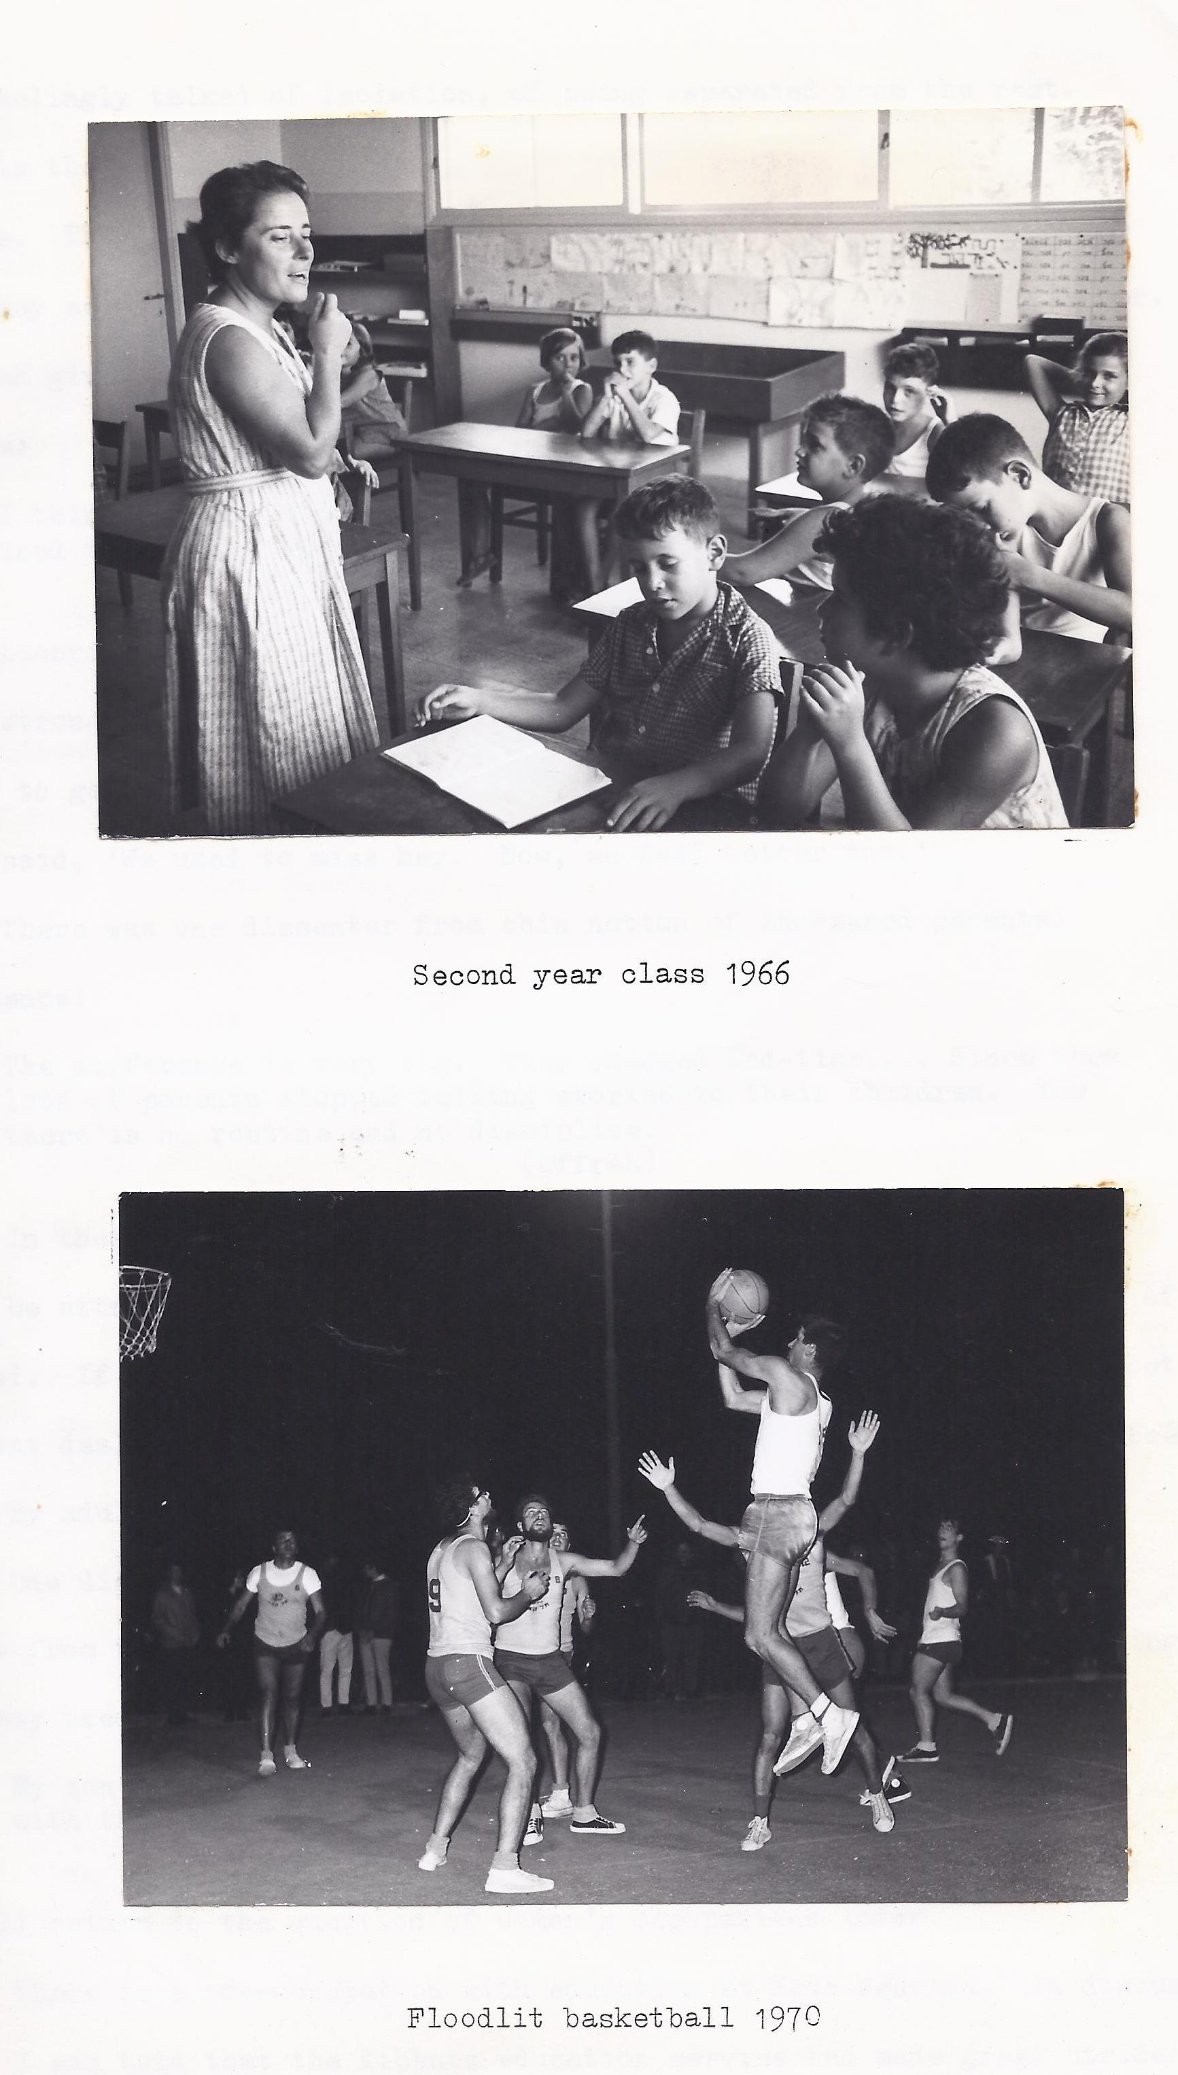

One disadvantage or advantage, depending on how one looks at it, stems from the fact that the parents are no longer as free in the evenings as they used to be:

*My son was three when took him home. Now all my life is spent*

*with the children. Only at night I have time for myself.*

*(Nomi G)*

I will return to the question of women's occupations later.

There is a pre-occupation with education at Sade Nehemya. In discussion I was told that the Kibbutz education services had made great strides forward in modernizing. There was a scheme in existence for training teachers and metaplot. Everyone was trained. In some ways the return of the family put a new light on the power and influence of the metapelet.

Uri explains:

*Our young parents made a big revolution ideologically. They were highly educated and came from a bourgeois, socialistic background. Twenty years ago there was only one line of education. Now we are very wise. The nurse says one thing. The teacher says another and the parents another. It is confusing for the children. We are not together in this.*

*(Uri)*

He has identified a source of difficulty that I have experienced and one that is only possible where the professionals, the parent and the child each have their spheres of power. This confusion could not have happened when the metapelet was solely in command. Although education was seen as a very important feature of the children's life it was by no means entirely positive:

*Children work less (on the Kibbutz) but learn more. Therefore they meet less people of the Kibbutz. They have much less connection, when they return to the Kibbutz after the army. It's like a new place.*

*(Ruth)*

The increasing demands of school life leave less time for working

in a laboring sense, on the Kibbutz. Children are expected to work but their playing has been catered for in many ways. There is a children's Zoo, an adventure playground which is floodlit at night, a football pitch and a floodlit basketball/volleyball court. This increased focus on the children enhances the place of the family in the Kibbutz. Many Kibbutzniks believe that: *'The Kibbutz is a paradise for children.'(Mikhail)* I think he is correct so far. However, I believe he forgot to include the parents.

1. How will the Kibbutz develop for children?
2. EDUCATION

'The Kibbutz system of education will get better; mainly for smaller children.'(Avram) 'Not very much going to happen. Better teaching methods.

*The influence of the nurse and teacher will get less.'(Schloomit)*

*In a few years we will move even more towards leisure time. With every close monitoring we have less need of special schooling. Parents know everything that's happening.*

*(Nomi G.)*

*Perhaps the children's house will become just a school.*

*(Yael)*

*We try to give all the children the chance to develop his own personality. There will be more emphasis on arts, hobbies and music. (Achi)*

Change has been rapid in the Kibbutz and these respondents, on the whole, seem to see things improving even more. Hidden too is the information that there will be further emasculation of the teacher and metapelet roles. More power will reside in the family.

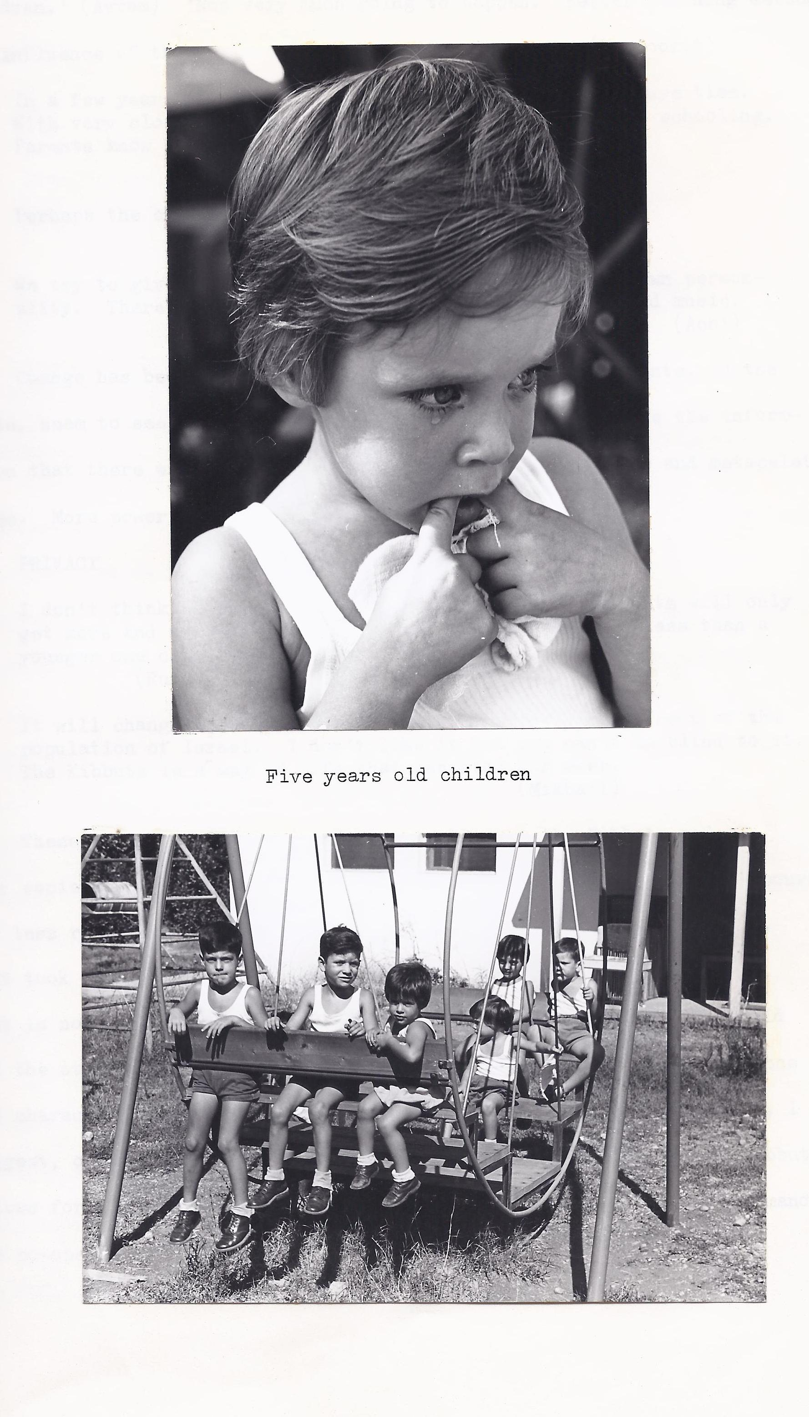

1. PRIVACY

*I don't think there will be any big changes. The Kibbutz will only get more and more private. The older Kibbutz changes less than a younger one can.*

*(Ruth)*

*It will change more towards the other ninety-seven per cent*

*population of Israel. I don't Iike it but you can't be blind to it. The Kibbutz is a way of life that can stay forever.*

*(Mikhail)*

These two see a lessening of the gap between the Kibbutz and the host society. The members of Sade Nehemya notice their younger neighbors are less resistant to change and, I would say, less open to new ideas. What took a year seven kilometers away took ten years at Sade Nehemya. That is not a very useful comparision since one Kibbutz was one year old and the other thirty-three. Each Kibbutz seems to have its own ambiance and character which cannot be replicated anywhere else. This depends, I suggest, on the collective personality of its members. The modern Kibbutz allows for greater individual and familial freedom and a lessening demand for co-operation.

c) WOMEN AND CHOICE

*Because of a lack of women willing to work in the children's houses the school may be transferred to Kfar Blum and then the children will be in contact with the outside world from the age of seven instead of twelve years.*

*(Magda)*

*Work for mothers may be arranged until twelve o'clock midday so that the children can be at home with their mother. I can't see it will change more*

*(Nomi A.)*

*In our schools there are no male teachers. It is not right.*

*(Esther O.)*

*I hope it will lead to a more equal society. The choices for women are much more limited. Either the children's houses, the sewing room or the kitchen.*

*(Aliah)*

The increase in Talmon's familistic tendencies tends it seems, to increase the likelihood of women returning to traditional roles. Choices for women are much more limited. The Kibbutz founders held as very important, the idea that all members could do all jobs. Women too, wanted to be seen as workers. Padarn-Eisenstark1(1973), evaluating the division of labour on the Kibbutz pointed out that men did the physical labour and women took up the main burden of the communal services and child care in spite of Kibbutz ideology. 'As a result,' he declared' 'the

division of labour between the sexes in the Kibbutz is paradoxically even more clear cut and "traditional" than the rest of Israel: seventy-nine per

cent of Kibbutz women (as against only thirsty-nine per cent of the total Israeli women –power) work either in education and child care or in service operations.'

It sounds as though the women are resigned to withdrawing from

even service occupations to be with their children. The idea that the Kibbutz will be able to have equal opportunities for women does not at first look feasible.

Gerson2 (1974), believed that 'the familistic solution of the women's problem has a regressive impact on women's position in the Kibbutz.' That was 1974 but the regression appears to be still there.

I would like to predict that what has happen in the more progressive European and North American countries will happen on the Kibbutz. Women will claim a sharing of roles with their menfolk. This will not be as a result of a concerted movement on the individual Kibbutz but will be a gradual change everywhere.

1. Padarn- Eistenstark, D.D. ( 1973) "Girls Education in the Kibbutz" International Review of Education p. 123
2. Gerson, M. ( 1974) op. cit. p. 50

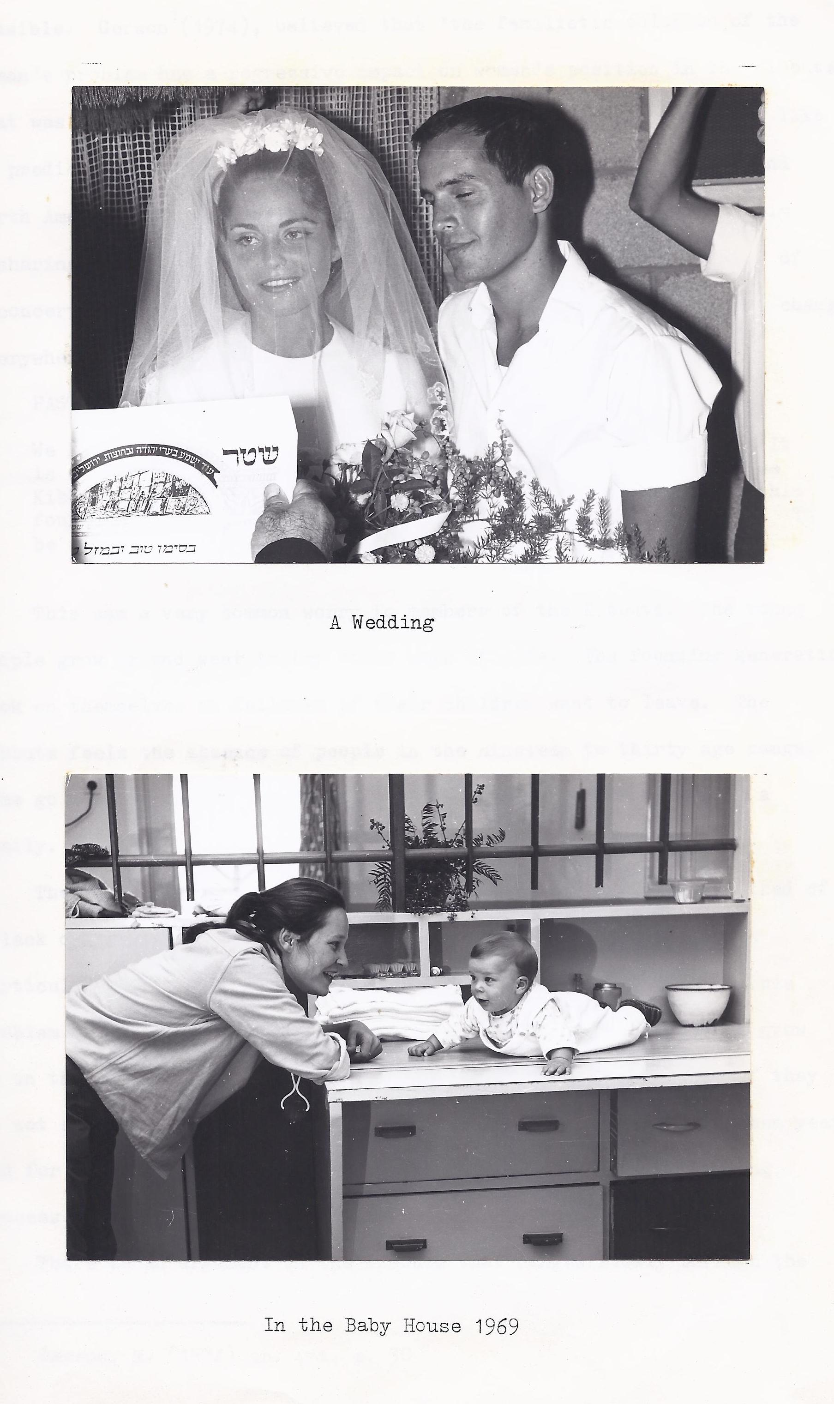

d) PAST AND FUTURE

*We haven't managed to educate our children to be Kibbutzniks. It is our fear that the young will leave Fifty per cent leave the Kibbutz.*

*Maybe it's natural to leave home. We didn't foresee this forty years ago. Ideologically, we haven't tried hard enough to be a member you must want to be a Kibbutznik.*

*(Lisa)*

This was a very common worry to members of the Kibbutz. The young people grow up and want to try other ways of life. The founding generation look on themselves as failures if their children want to leave.

The Kibbutz feels the absence of people in the nineteen to thirty age range. Some go away to return later when they are married or are starting a family.

The small group of teenagers I spoke to via an interpreter talked of a lack of privacy and little connection with the older members. One in particular missed the company of people of her own age or older. This problem of the Kibbutz will continue, I am sure. Young people who grow up on the Kibbutz will always want to see the outside world even if they do not stay in it very long. Compulsory national service at eighteen years old for two years is the unnatural break that starts this estranging process.

There is an argument in the Kibbutz that ranges slowly through the sitting room and meeting halls and will eventually engulf them. It surrounds the direction of development. Will the Kibbutz lose any resemblance to the original model or will it survive without loss of face to continue its communal tradition. Here is one opinion, which represents only one side of the argument:

*I think the Kibbutz is finished; perhaps not in my lifetime. It is not a natural way to live. Perhaps the profits will be divided according to merits as in a Moshav Shitufi.1*

*(Dov)*

It is one of the features of the Kibbutz that every issue is debated endlessly. It is an enviable position. Their democratic system makes it worthwhile arguing. One might get what one wants. The specter of the Moshav is particularly galling to those pioneers who can see the pressure for an even more private life. It is as if they are being robbed of their original beliefs.

1. Moshav- privately owned farm, sharing facilities with other moshavim.

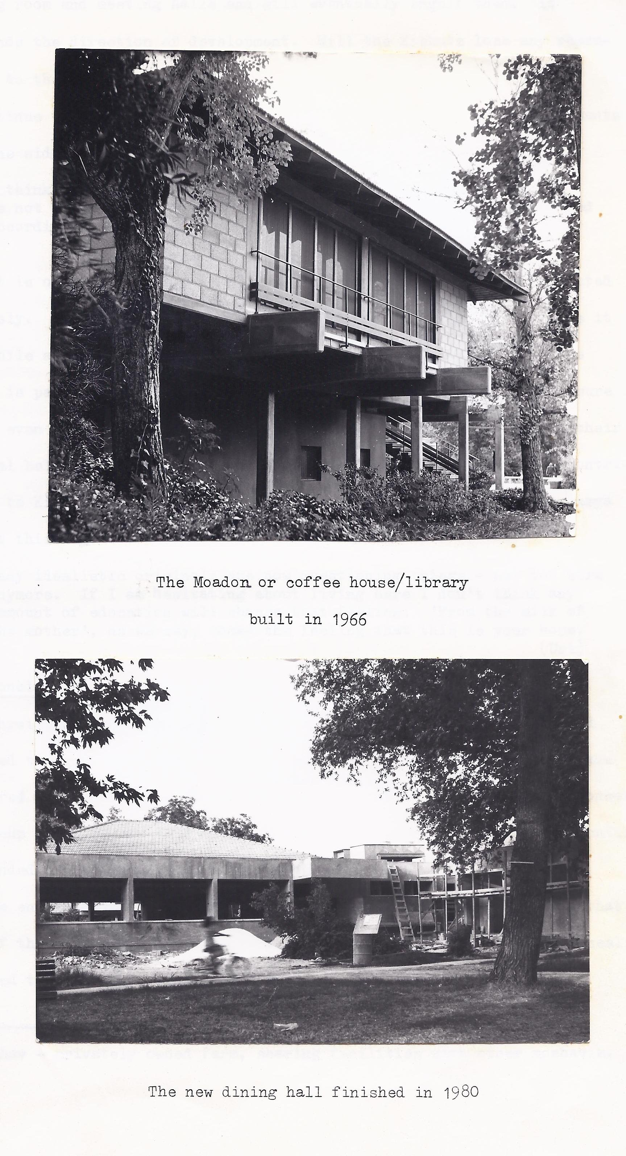

I see each generation making its own particular contribution to Kibbutz life. One of the young men who grew up in Sade Nehemya sees it this way:

*Many idealistic originals are now questioning things-not to sure anymore. If I am hesitating about living here I don't think any amount of education will change that feeling. 'From the milk of the mother', as we say, come the feeling that this is your home.*

*(Uri)*

9. Conclusions

Physical conditions in the early days were extremely primitive and dictated that children were centrally organized. Some mothers would have preferred to have their children at home but were persuaded by their concern for group cohesiveness to deny their feelings. An ideological justification surrounded the continued use of the children's house system, after the hostile environment had been subdued. However, it must be recognized that many of the pioneers of Sade Nehemya were idealists who, with Zionist zeal, intended to create a 'new society'.

This society was to be egalitarian, anti-religious and agrarian. They sought to reverse the traditional Jewish values of scholarly learning, parental authority, sex-role stereotypes and an obsequious standing in their host European society.

However, the pioneers often see themselves as failing to educate their children to be Kibbutzniks. It seems they have fallen into the trap that many parents set up. That is, they want their children to want what they want. Parents who believe that they know best what their children should do as adults can only be disappointed. When the pioneers were young men and women, they wanted to make their view of the world reality. Having created it, in the shape of the kibbutz, they felt disappointed that their children did not feel the same way. This, I think, is an issue of fundamental importance. I suggest that it is more helpful to all concerned if children were regarded by parents in the way that Gibran1 (1923) does.

1. Gibran, K. (1923) The Prophet ( Heinemann, London)

He said:

… They come through you but not from you,

And though they are with you yet they belong not to you.

You may give them your love but not your thoughts,

For they have their own thoughts.

You may house their bodies but not their souls,

For their souls dwell in the house of tomorrow,

which you cannot visit, not even in your dreams.

You may strive to be like them, but seek not make them like you.

It seems a pity that people who created a unique life style should feel failures. The evidence suggests that they were somewhat unrealistic with regard to their children's need for autonomy but that is all.

**Appendix I : Original questions**

1. Name?
2. Age?
3. Original Nationality?
4. Male or female?
5. Children?
6. Born in the Kibbutz?
7. When did you enter Israel?
8. When did you begin your stay at Sade Nehemya?
9. For what reason did you leave your original country?
10. What was your status in your original country?
11. What made you decide to come to the Kibbutz?
12. From your knowledge, how has the Kibbutz method of child-rearing changed?
13. Why have these changes taken place?
14. Can you say which group or individual was responsible for those changes?
15. In what ways has your own upbringing influenced the way you bring up your own children?
16. How do you see the Kibbutz developing in the area of child education?

Appendix II Chronology

1. Slept for the first time on the Kibbutz ground 19 th Dec. 1940 in a tent camp.
2. Wooden houses May 1941.
3. First dining room, sewing room, bedroom/library was an old police station brought from Akko at the end of 1941.
4. In 1943 the first children came. They were about 2 1q5 – 3 years. The first children's house built on the site of the present library, which is at the center of the Kibbutz.
5. In 1947 the first school room was used.
6. In 1948 the children were evacuated to Haifa from May until the end of the war (of Independence).
7. Till 1951 there was a common shower for men and women. Only then was built the first private ones.
8. In 1955 the first proper dining room was opened. It was wooden but with a solid floor. (This was superseded by a concrete construction in 1980).
9. In 1963 the children were taken to Kfar Giladi in the middle of the night because of the flood. The waters of the Jordan reached as far as the middle of the Kibbutz.
10. In 1967 the children slept for seven days in the bunkers. This was the beginning of the big pressure to take them home. The first foreign group of volunteers arrived.
11. In 1972 some parents took the law into their hands and started to have their children at home in the night.
12. In 1973 the Yom Kippur war broke out. The children spent six weeks in the bunkers. This appears to have been the last straw. They never went back to sleep in the children's house.

**Appendix III: Backgrounds**

FOUNDERS

Lisa Gidron

58 yrs. Czech origin Born in Vienna

Married 3 sons born on Kibbutz

She was a Jew from German part of Bohemia and spent the war in

Czech concentration camps. Her parents left in 1939. She came to

Israel in April 1946, and to Sade Nehemya in 1963 from Neyot

Mordechai where she had been for seventeen years(Neyot Mor-

dechai is about 5 km. away) in order to marry.

Lisa had been in the Zionist youth movement from the age of

thirteen. She was educated to emigrate to Israel; to be a pioneer.

She was living in the ghetto of Theriesenstadtat the time, when she

started to do gardening as a preparation for Israel, because

she wanted to have a practical profession. It must be remembered

that in those pre-war years Jews were not allowed in the

university.

Ruth Kegel

53 yrs. Czech origin (Born on the Kibbutz)

Married for 34 yrs. 1 son, 2 daughters born on Kibbutz

She arrived in Israel in 1939 and in Sade Nehemya in May 1945.

Because the war was coming to Czechoslovakia. She came to

Israel with children's Aliyah at the age of thirteen. Her parents

came at a different time.

Joshua Vogel

64 yrs Born in Poland

He lived in Vienna from fourteen years old. He came to Israel

in 1939, and arrived in Sade Nehemya in 1941. He left Austria

because of the German invasion. He worked in Vienna as an imp-

ortant clerk in a ladder factory. Joshua was, at the time, in a

Zionist organization which formed the group that came to the

Kibbutz at the time.

Avram Zoham

57 yrs. Czech origin Originally Rudolf Steiner

Married 4 children born on the Kibbutz

He came to Israel 1939 and joined Sade Nehemya in 1941. He was a

student at a college when Hitler came to power. He left soon after a

convinced Zionist and idealist. He spent six years in the army which

was very useful in the War of Independence.

Schloomit Lobshtein

65 yrs. Dutch origin

3 children all born on the Kibbutz

She came to Israel in 1935, and joined Sade Nehemia in 1937. She

was a member of the Zionist Student youth movement in Holland.

Schulamith Ben Dror

German origin

1 son

She moved to Holland in 1936. She was taken to Bergen-Belsen during the war and held in captivity with her son Mikhail. In 1944 she was exchanged for German noncombatants from Palestine. She arrived

at Sade Nehemya in 1944. She was the daughter of a well-known writer.

**FIRST GENERATION**

Nomi Abrams

36 4 children born in the Kibbutz

Mikhail Ben Dror

38 5 children born in Holland

He came to Israel at the age of three.

Yael Misrady

Married No children

Nomi Gabai

28 yrs 3 children born on the Kibbutz

Gidon Shelah

40 yrs 3 children born on the Kibbutz

He was the first boy born on the Kibbutz.

Aldat Shoham

35yrs 3 children born on the Kibbutz

Hannah Noshonni

32 4 children born on the Kibbutz

She married twice; her first husband was killed in the war.

**LATE COMERS**

Esther Bacharah

30 yrs Iranian origin

Married

2 children born on the Kibbutz

She came to Israel in 1952 and to Sade Nehemya in 1974 to marry.

Rachel Metzer

34 yrs Morroccan origin

Married 4 children born on the Kibbutz

She came to Israel when she was nine years old in 1955 and joined a

Youth movement (Chevrat Noar) in Kiryat Shemona, a town near Sade

Nehemya. She came to the Kibbutz two years later along with thirty-others, all from the same urban organization.

Dov Gershman

43 yrs. Argentinian

2 children born on the Kibbutz

He came to Israel and straight tot eh Kibbutz in 1969. He left Argentina because of personal problems and came to learn Hebrew at the uipan on the Kibbutz. He stayed on.

Offrah Taus

44 yrs. Born in Israel

Came to the Kibbutz to marry a Kibbutznik.

Dahliah Weinemman

44 yrs. Originally Czech.

4 children born on the Kibbutz

Between 1943 and 1945 she was hidden by a Polish family and returned to her birth town to find no parents. She joined a Zionist youth group in 1948 and came to Israel in 1949. Until 1939 her family were described as upper middle class.

Achai Bar Levi 3 children born on the Kibbutz

Aliah Gershman

Married 2 children born on the Kibbutz

Dutch origin

Came in 1973 to marry Dov.

Uri Gretzer

43 yrs originally Czech.

Married 2 children born on the Kibbutz

He joined a Zionist organization at the age of eleven or twelve. His father left in 1941 and Uri got a post card from Theriesenstadit after one week; and then nothing. He stayed in the movement and became a Schlichim (missionary)for the Zionist Pioneer movement and he was allowed to stay in Czechoslovakia until 1949.

Magda Ophir

30 yrs Panama origin

Married 3 children born on the Kibbutz

Came as a volunteer in 1967. "I came because I thought it was a better way of life and maybe it was possible to spread it to South America."

**Bibliography**

Banks, L.R. (1962) An End to Running (Penguin, London)

Baratz, J. (1954)A Village by the Jordan (Harvill Press,

London)

Berger, P. and (1967) Social Construction of Reality(Allen

Luckman, T. Lane, London)

Bettelheim, B. (1969)The Children of the Dream (Paladin,

London)

Bowlby, J. (1951) Maternal care and the Growth of Love

(W.H.O. Monograph)

Darin-Drabkin, H, (1962) Patterns of Co-operative Agriculture

In Israel (Israel Institute for Books, Tel Aviv)

Dayan, Y. (1961) Envy the Frightened (Weidenfield &

Nicolson, London)

Diamond, S. (1957)"The Kibbutz: Utopia in Crisis"

Dissent lV

Gerson, M. (1974) 'The Family in the Kibbutz' J. Child

Psychol. Psychiat. vol. 15 pp. 47-57

Gibran, K. (1923) The Prophet (Heineman, London)

Infield, H. F. (1944) Co-operative Living in Palestine

(Dryden, New York)

Laqueur, W. (1962) Young Germany: History of the

Youth Movement (Routledge and Kegan

Paul, London)

Leon, D. (1969 The Kibbutz; " A New Way of Life"

(Pergamon Press, Oxford)

Madar, M. (1972) The Reality of the Kibbutz (Kibbutz

Representatives, London)

Padarn-Eisenstark, D.D. (1973) "Girls" Education in the Kibbutz'

International Review of Education 19

Rabin, A. I. (1965) Growing up in the Kibbutz

(Springer Publishing Company Inc.,

New York

Rapaport, D. (1958) 'The study of Kibbutz Education

And it's bearing on the Theory of

Development'

American Journal of Orthopsychiatry

28 pp. pp. 587-97

Rogers, C. (1967) On Becoming a person

(Constable, London)

Spiro, M.E. (1958)The children of the Kibbutz

(Harvard University Press, Cambridge,

Mass.)

Spiro, M E. (1956)Kibbutz: Venture in Utopia

(Harvard University Press, Cambridge,

Mass.)

Talmon, Y. (1972) Family and Community in the

Kibbutz (Harvard University press,

Cambridge, Mass.)

Weingarten, M. (1955) Life in a Kibbutz

(Reconstructionist Press, New York)